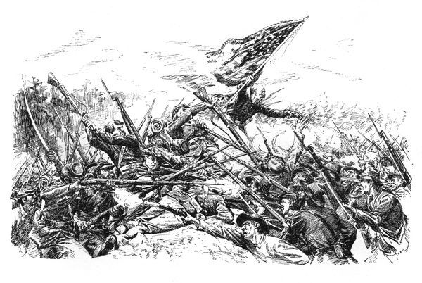

# Course Syllabus

**Roy C. Ketcham High School**

**Social Studies Department**

**The American Civil War Elective**

**Fall 2021**

## Instructor Information

Instructor: Mrs. Johnson

Room Location: Room 105

E-mail: [jessica.johnson@wcsdny.org](mailto:jessica.johnson@wcsdny.org)

Extra Help Time: By appointment

## Course Identification

Course Number: D760

Course Name: American Civil War

Course Location: Room 105

Prerequisites: Social Studies 8

## Course Description/Overview

This American history elective examines one of the most crucial turning points in American history – the Civil War. This one-semester course describes the major points of contention between the North and the South, including differing viewpoints on slavery. Students study the lives of key figures such as Abraham Lincoln and Robert E. Lee, the leaders of the North and South, and gain a glimpse into the daily life of a soldier. Examining pivotal battles and troop movements, students gain an understanding of the importance of war strategy. There will be a final examination given at the end of the semester.

**Course Resources**

### Course Website(s)

* [**https://www.wappingersschools.org/cms/Workspace/Section/Section.aspx?DomainId=1477**](https://www.wappingersschools.org/cms/Workspace/Section/Section.aspx?DomainId=1477)

### Required Course Text

* [**https://www.mrlocke.com/US_History/book.html**](https://www.mrlocke.com/US_History/book.html)

### Course Supplies

* A 3-ring binder (no preference), looseleaf paper, and plenty of writing utensils (pencils or pens).

## Course Learning Objectives

Upon successful completion of this course, students will be able to:

* compare and contrast past events and current issues
* identify recurring themes in history
* understand the strategies and major battles of the early years of the Civil War, 1861-62
* discuss how the outcome of the conflict is shaped in 1863-1864
* become acquainted with noteworthy individuals of the era
* see the various factors that led to countrymen facing countrymen in vicious, bloody combat

### Grading Policy

Grades will be based on the following:

| **Course** **Component** | **Percentage** |
| --- | --- |
| Classwork | 10-20% |
| Homework | 10-20% |
| Quizzes | 30% |
| Tests/Essays | 40% |
| **Total Points** | **100%** |

### Late Assignments

* Students receive full credit (100%) on an assignment if the student was not in class due to illness or other legal absence.
* Assignments are accepted for half-credit (50%) one day after the original due date. After this, the assignment drops to 10%.
* Students are expected to complete all posted homework assignments if absent from class in a timely manner.

## Course Policies

* Class rosters are provided to me with the student’s legal name. I will gladly honor your request to address you by an alternate name or gender pronoun. Please advise me accordingly early in the school year by the manner in which you feel comfortable (speak to me privately after class, email, etc.) so that I may make appropriate changes to my records.
* It is my goal to promote an atmosphere of mutual respect in the classroom. Please raise your hand when you wish to speak or ask questions, please do not speak when others are speaking, please speak to each other in a respectful manner, etc. Foul language and inappropriate behavior are not tolerated.
* Everybody has to use the bathroom! When you wish to go, please ask first and then use the soap up front. This is a privilege that should not be abused.
* Seating will be at the discretion of the educator and seats will be reassigned every five weeks.
* Cellphones, earbuds and other electronic devices are not permitted to be used in class. The focus of class time should be interaction between students, and with the educator. Any other unauthorized activities are likely to be distracting to other students and the educator,, and you will be asked to please put it or them away.

## Academic Integrity Rules

* Students may discuss homework assignments, but are expected to individually work/write/solve any and all submitted work.
* All authorized resources used, including but not limited to internet sites (i.e. Chegg, Study Soup, Course Hero, etc.), should be appropriately cited.
* Plagiarism means submitting work that somebody else wrote, copying passages (sentences, paragraphs, or phrases) that somebody else wrote without citing the source (where you got it from), or turning in work that you wrote for another class.
* Any or all of the above will result in your assignment receiving a zero for a grade.
* Please check your Google Classroom daily, as you are responsible for completing the posted assignments - assignments are graded on a percentage basis and notes will not be posted until the end of the unit.
* Extra credit may be offered on certain assignments, and there are also separate extra credit assignments from time to time throughout the marking period.

## Course Schedule

* [**https://www.wappingersschools.org/cms/lib/NY01001463/Centricity/Domain/49/WCSD%202021_22%20School%20Calendar%20v4.pdf**](https://www.wappingersschools.org/cms/lib/NY01001463/Centricity/Domain/49/WCSD%202021_22%20School%20Calendar%20v4.pdf)