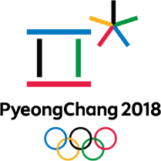 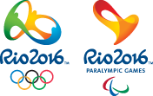

***Winter or Summer Olympic Poster***

You will create a poster celebrating either the Winter or Summer Olympic Games. You may choose either Rio 2016 or Tokyo 2020 for the summer games or PyeongChang 2018 for the winter games.

You must include:

The Olympic logo (5 points)

The start and end dates of the games written in Italian (5 points)

The Olympic mascots – pictures, names and type of animal if possible (5 points)

At least 10 events being presented at these games translated into Italian and illustrated (10 points)

Show the flags and label at least 12 countries (labelled in Italian) competing in the games (Italy and the U.S. must be included) (10 points)

provide the medal results for Rio 2016 or PyeongChang 2018 in Italian for at least the top 5 nations. (5 points) gold = oro, silver = argento, bronzo = bronze

Information can be found on the official Olympics website –

<https://www.olympic.org/pyeongchang-2018>

<https://www.olympic.org/rio-2016> https://www.olympic.org/tokyo-2020

This must be colorful and neatly done. It can be no bigger than a half sheet of poster board and no smaller than 8x10. Art can be drawn or computer generated.

**Due date March 8, 2019 Done Points**

|  |  |  |
| --- | --- | --- |
| The Olympic logo for either Rio or PyeongChang |  | **5** |
| The start and end dates of the games |  | **5** |
| The Olympic mascots |  | **5** |
| At least 10 events being presented at these games |  | **10** |
| Show the flags and label at least 12 countries |  | **10** |
| provide the medal results |  | **5** |