International Organizations

Growing Distrust

Containing Soviet Expansion

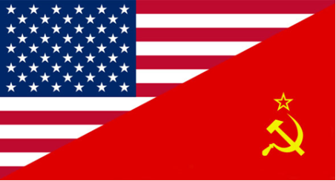

The Arms Race

What happened in China in 1949 [841]?

Define arms race [855]:

The Korean War

Name:_______________________________

What nations were a part of the Warsaw Pact [841]?

Define superpower [855]:

What happened on June 25, 1950? [850]

How did the US respond to this event? [850-51]

What did Senator McCarthy accuse innocent people of being? [852]

Fears at Home

The Cold War

What caused the Berlin Airlift? [838-839]

Define airlift [838]

What did the Soviet Union develop? What did this now mean [841]?

Shocks of 1949

What nations were part of NATO? [840]:

Define Iron Curtain [837]:

What are the main goals of the United Nations? [840]

What did George Marshall propose in June of 1947? [838]

Define containment [837]:

Explain the Truman Doctrine [837]: