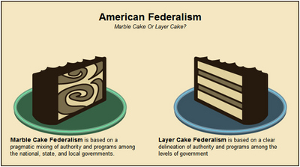**AP US GOVERNMENT & POLITICS**

**CHAPTER 3 TERMS**

1. Federalism
2. Necessary and Proper Clause
3. Unitary System
4. Supremacy Clause
5. Tenth Amendment
6. Bill of Attainder
7. *Ex Post Facto* Laws
8. Full Faith and Credit Clause
9. Privileges and Immunities Clause
10. Extradition Clause
11. Interstate Compacts
12. Dual Federalism (Layer Cake)
13. Nullification
14. Sixteenth Amendment
15. Seventeenth Amendment
16. The New Deal
17. Franklin Delano Roosevelt
18. Cooperative Federalism (Marble Cake)
19. Categorical Grant
20. New Federalism
21. Ronald Reagan
22. Block Grant
23. Devolution Revolution
24. Unfunded Mandate
25. Progressive Federalism