Nome:
Data:
In Italian create a list of all of the possible sports you can play based upon the picture depicted in each season. Please also label the season (“la stagione”) as a refresher from last year. You will have cinque minuti! ☺

- La stagione: : __________________
Gli sport: __________________ __________________
__________________ __________________
__________________ __________________


- La stagione: __________________
Gli sport: __________________ __________________
__________________ __________________
__________________ __________________

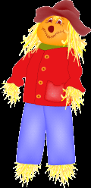
- La stagione: __________________
Gli sport: __________________ __________________
__________________ __________________
__________________ __________________


- La stagione: __________________
Gli sport: __________________ _ _________________
__________________ __________________
__________________ __________________

