UNIT II TERMS: POLITICAL BELIEFS AND BEHAVIORS

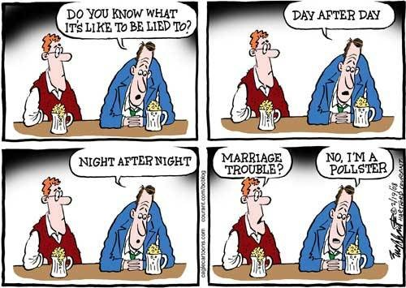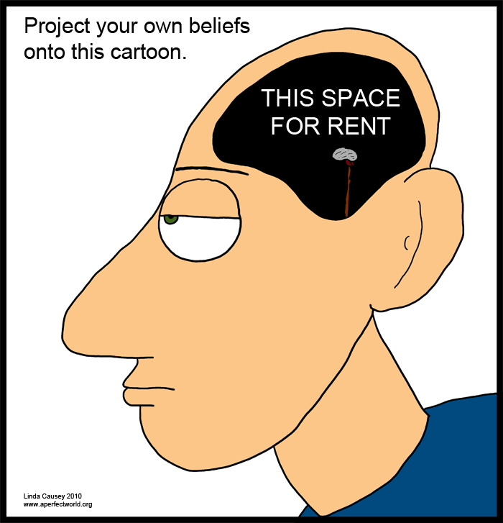

Chapter 4: The Political Landscape (pgs 78-94)
- Political Culture

- Liberty

- Equality
- Political Ideology

- Civic Duty

- Individual Responsibility

- Civic Competence

- Class Consciousness

- Orthodox

- Progressive

TENETS OF AMERICAN POLITICAL CULTURE

DIRECTIONS: Use pgs. 79-81 in your text to explain and describe the key points of each tenet of American Political Culture. Afterward rank each tenet in terms of importance.

Priority | Tenet | Key points
 | Personal Liberty
 | Equality
 | Popular Consent, Majority Rule and Popular Sovereignty
 | Civil Society
 | Individualism
Religious Faith and
Religious Freedom

