Math Problem of the Week
#9
Due Friday, December 10, 2010

Hello Animal Explorers,

Now that you know a bit about the penguins of Antarctica let’s learn about the polar bears in the Arctic. Have you ever heard of Global Warming? Scientists have observed that the world is getting warmer, and that it is effecting the Arctic region much faster than they thought it would. Polar bears use the sea ice to hunt, breed and sometimes den, so melting ice greatly affects the bears population.

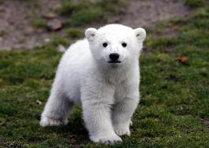

- A polar bear needs a few hundred miles of land to live on (let’s say 200). If a polar bear is living on a piece of land that is 800 miles, and every year 1/2 of it melts, how long will it be before the polar bear has to leave to find a new home?

years.

- Polar bear Mommies usually have twins, (2 cubs at once). If the mom has 6 sets of cubs in her life, how many cubs will she have had?

cubs.

Safari Lottery #9
Circle either the real polar bear or the drawn one.
Whichever is picked the least will earn .

