Math Problem of the Week
#8
Due Friday, December 3, 2010

Hello Animal Explorers,

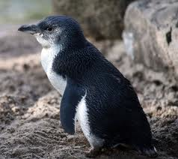
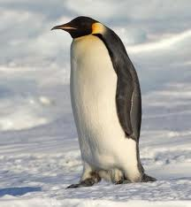
This week we’ll be finishing up with Australia and moving on to Antarctica. Australia’s Little Penguin is the smallest species of penguin, measuring 16 inches and weighing just over 2 pounds. The largest of all the penguin species is the Male Emperor Penguin from Antarctica they measure about 48 inches tall and weigh an average of 75 pounds. While we think of penguins being around snow and ice, the Australian, little penguins, live in weather around 72 degrees Fahrenheit. Emperor penguins do live through some of the coldest weather on the planet -112 degrees Fahrenheit. That’s 112 degrees BELOW 0!

- How many inches taller than the little penguin is the emperor penguin?
inches.

- How many degrees colder is it in Antarctica than in Australia?

degrees.

Safari Lottery #8
Circle either the Emperor penguin or the little penguin.
Whichever is picked the least will earn .

