EXPLORE THE WORLD WITH SHEAFE’S FLAT BLUEBIRD
Due: Friday, December 2, 2011
STUDENT NAME: __________________________________________________ ROOM _______________
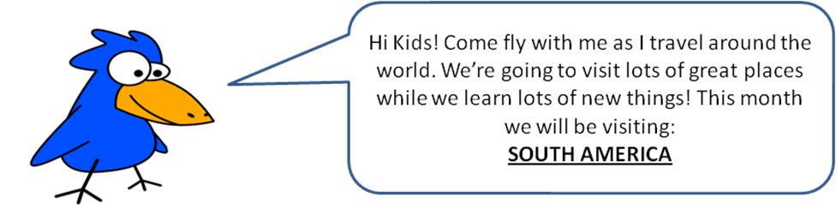
While in South America, Flat Bluebird has been studying the Amazon Rainforest. When someone mentions the rainforest, your first thought might be a lot of trees in South America and the Amazon. You’re right! Flat Bluebird is flying through, unwrapping a gift put in layers and layers of forest. A rainforest is usually divided into four layers. Each layer has its own distinct features and houses different kinds of animals and plants. Forest floor - All trees in the rain forest start their lives here in this layer. On the damp ground, we see lots of fallen leaves and fruits, decaying trees, and fungi. They are food sources for many animals. Tapirs, termites, and scorpions are among many of the animals that can be found here. Understory - Immediately above the forest floor. The understory consists of tree trunks, saplings, small ground plants (such as dwarf palms), and vines. Residents here include bees, snakes, frogs, and leopards. Canopy - Moving up from the understory, we are now in the third layer, the canopy. Treetops in rain forests have leaves so densely packed that they form a "green blanket" in mid-air. We call this "green blanket" the canopy. The canopy shields sunlight from reaching the forest floor and the understory, making both layers very shady. Most of the rain forest animals live here, including several familiar faces - toucans, parrots, sloths, and monkeys. Emergent - When we ride in a helicopter above a rain forest, we first notice the canopy extending for miles and miles.
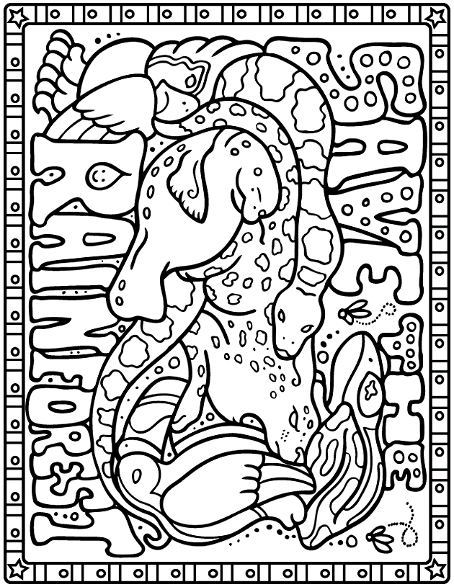
- Color the words Rainforest Green
- Color as many Rainforest animals as you can (Hint: there are 6 animals)
Want more of a challenge? Look on the back!

For more of a challenge, answer the following questions:
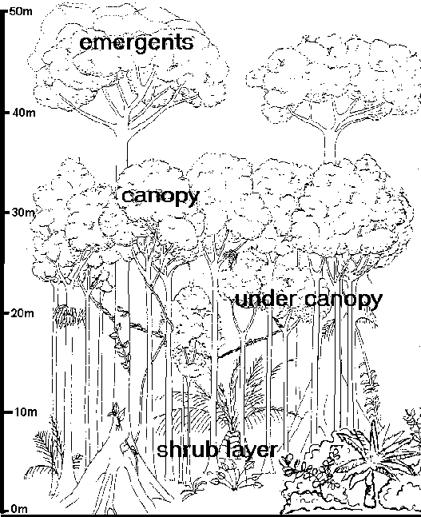
Which of the following correctly lists the four layers of rain forests, from the highest to the lowest?
Forest Floor -> Canopy -> Emergent -> Understory
Canopy -> Emergent -> Understory -> Forest Floor
Emergent -> Canopy -> Understory -> Forest Floor
Forest Floor -> Understory -> Canopy -> Emergent
Why are rain forests so important?
Because they provide us plenty of food
Because they produce oxygen
Because they can be used to develop medicines
All of the above
Which of the following statements about rain forests is true?
The emergent layer is the highest layer of rain forests.
Most of the rain forest animals live in the forest floor layer.
The Amazon is the second largest rain forest in the world.
Most of the rain forest animals live in the understory layer.
The "green blanket" mentioned in the article is the ____________ layer of rain forests.
Understory
Canopy
Emergent
Forest floor

