EXPLORE THE WORLD WITH SHEAFE’S FLAT BLUEBIRD
Due: Friday, November 18, 2011
STUDENT NAME: __________________________________________________ ROOM _______________

This week, Flat Bluebird is flying to Brazil! Brazil is the largest country on the continent of South America. It is the fifth largest country in the world. It covers as much territory as almost the entire continent of Europe and is just slightly smaller than the United States. Brazil borders almost every country in South America except Ecuador and Chile, and is also bordered by the Atlantic Ocean on the east. Brazil is the most popular country in South America. Brazil's flag is a deep green banner with a yellow diamond enclosing a night-blue, star-studded Southern Hemisphere sky. The sky depicts 27 white, five-pointed stars (one for each state and the Federal District); the stars are arranged in the pattern of the night sky over Rio de Janeiro. A banner across the sky reads, "ORDEM E PROGRESSO," which means "order and progress" in Portuguese. Did you know that Brazil is the only country in South America where its residents speak Portuguese?
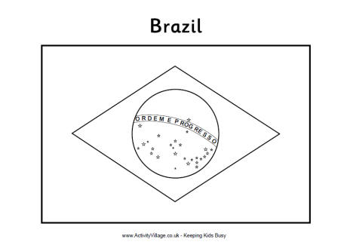

Color the flag of Brazil correctly using the information mentioned above.
Want more of a challenge? Look on the back!

For more of a challenge, answer the following questions:

Brazil is situated in _____.
Africa
Central America
South America
North America

Brazil is the third largest country in the world.
False
True
Brazil is the most popular country in the _____.
South America
Western hemisphere
Southern hemisphere
World

Which ocean makes up the eastern border of Brazil?

