EXPLORE THE WORLD WITH SHEAFE’S FLAT BLUEBIRD
Due: Thursday, November 10, 2011
STUDENT NAME: __________________________________________________ ROOM _______________
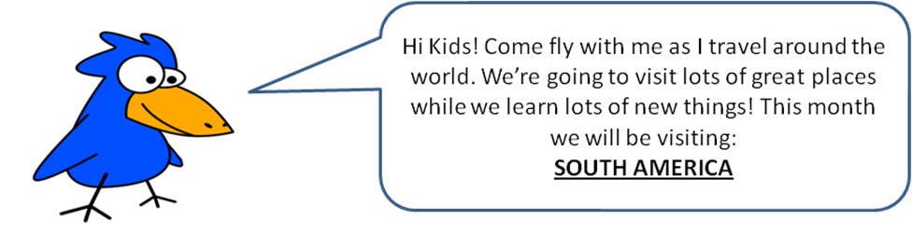
This week, Sheafe’s Flat Bluebird is really flying south – all the way to South America! South America is the fourth largest continent. It is located in the Western Hemisphere; most of it is in the southern hemisphere. It is divided into 12 countries: Peru, Uruguay, Bolivia, Colombia, Paraguay, Ecuador, Argentina, Chile, Suriname, Venezuela, Guyana and Brazil. South America is connected to North America by the Isthmus of Panama.
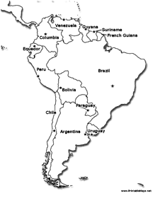
On the map, color the country of Brazil blue.
Circle true or false: North America and South America are connected. TRUE FALSE
There are 12 countries in South America. TRUE FALSE
Want more of a challenge? Look on the back!

South America is almost completely surrounded by water. The Pacific Ocean borders it on the west and the Atlantic Ocean borders it on the east. North America and the Caribbean Sea lie to the north and west. The continent is joined with North America at the border of Colombia and Panama.

Using the information above and on the front, answer the following questions.

- South America is mostly in which two hemispheres?
Northern and eastern
Northern and western
Southern and western
Southern and eastern

- What makes up the western border of South America?
North America
The Atlantic Ocean
The Caribbean Sea
The Pacific Ocean

- Write the names of the 12 countries that make up South America in ABC order.

