EXPLORE THE WORLD WITH SHEAFE’S FLAT BLUEBIRD
Due: Friday, November 4, 2011
STUDENT NAME: ___________________________________________________ ROOM _____________

It’s starting to get cold in the United States, so Sheafe’s Flat Bluebird is flying south to Mexico. Did you know there are over 200,000 different species of plants and animals in Mexico? Mexico has over 700 species of reptiles, over 400 species of mammals, close to 300 species of amphibians and more than 50 different species of hummingbirds.

Here is information are two animals that live in Mexico, the keel-billed toucan and the giant toad. Color the animals by following the directions in their descriptions.

KEEL-BILLED TOUCAN GIANT TOAD

The keel-billed toucan is brightly colored. Its The giant toad often blends in with its
body is covered with black feathers, with red and surroundings to hide from its predators.
white under and on top of its tail. The toucan has The toad’s back and side are greenish-
green skin around its eyes. The bird has a yellow brown or reddish-brown. Their bellies are
face and throat and stands on two blue legs. yellow or white, with darker spots.

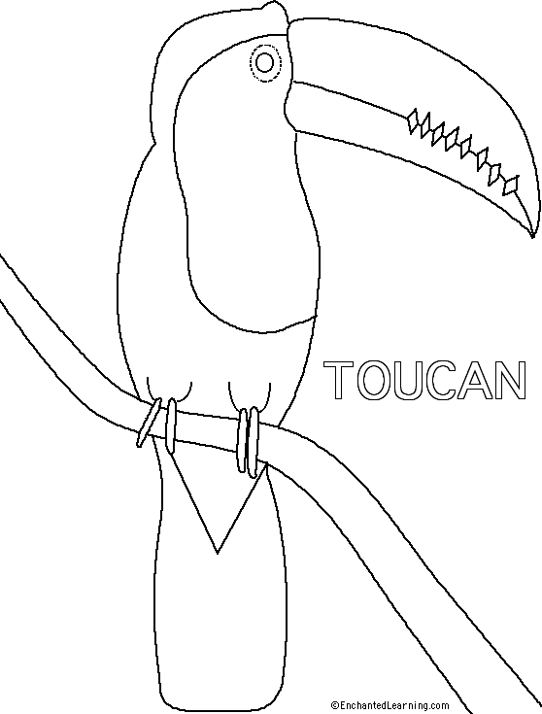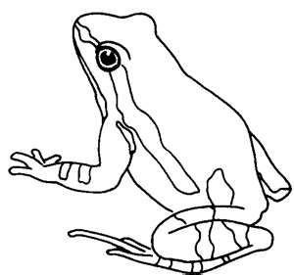

Want more of a challenge? Look on the back!

Want more of a challenge? Look on the back!

Using the information below and what you know about the different animal groups, sort the following animals that live in Mexico into the correct animal group.

Mammals – warm-blooded (bodies are built to maintain just about the same temperature all the time, regardless of the outside temperature); have fur or hair; drink milk that comes from their mother’s bodies; vertebrates (have a backbone). Examples: cats, dogs, whales, dolphins, foxes, bears, bats.

Reptiles – cold-blooded (bodies react to the temperature of their surroundings); scales protect their bodies; born on land; born with strong instincts so they are on their own at birth. Examples: snakes, alligators, crocodiles, tortoises and lizards.

Amphibians – spend their lives in the water and on land (begin their lives in water with gills and tails then develop lungs and legs for their life on land); cold-blooded. Examples: frogs, toads, salamanders or newts.

Birds – have feathers; warm-blooded; egg-laying vertebrates. Examples: pelicans, flamingoes, toucans.

keel-billed toucan macaw collared lizard jaquarundi (cat)

Mexican vine snake Morelet’s crocodile prairie dog brown pelican

bats jaguars Mexican tree frog dolphins

giant toad flamingo Mexican mud turtle parrot

Mexican horned lizard

Mammals

Reptiles

Amphibians

Birds

