**EXPLORE THE WORLD WITH SHEAFE’S FLAT BLUEBIRD**

Due: Friday, October 14, 2011

STUDENT NAME: ___________________________________________________ ROOM _____________

North America is the continent we live on. North America is made up of 3 major countries: Canada, Mexico and the United States of America (our country). North America stretches from the Arctic Ocean (where it is very cold) almost all the way to the equator (where it is very hot). On the map below, color Canada red, color Mexico green and color the United States purple. Water is around North America; color the water blue.

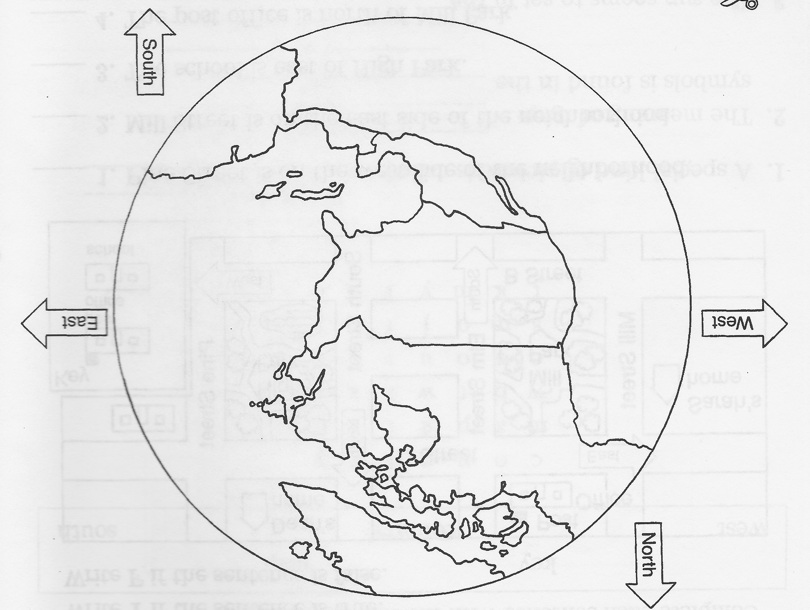

Want a more challenging map? Turn the page over!

