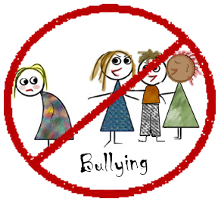 | CLASS PLEDGE

- We won’t bully others.
- We will help students who are being bullied.
- We will include students who are left out.
- We will report any bullying we know about or see.

Signed: ____________________________________

