Miss Hoff’s Class Room 204
Week of September 23 – September 27
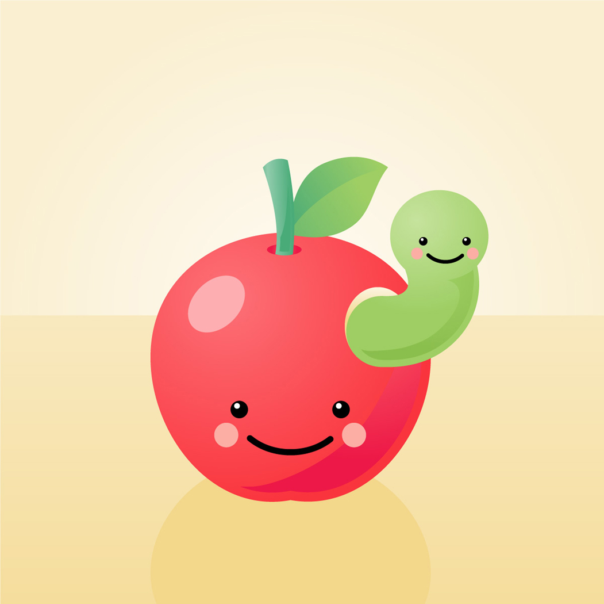

Look What We Will Learn This Week!

Reading: This week, our class will learn how to use Post-its and thinkmarks to track our thinking across a book. Also, we will focus on decoding by beginning and ending sounds to help us tackle tricky words.

Language Arts: Our class will learn about statements and questions. In Writer’s Workshop, we will learn how to unfreeze the characters in our writing by having them move and talk and telling the events of the story in small steps. Also, we will learn how to show not tell what is happening in our written texts.

Math: This week, we will review the addition strategies of near doubles and making ten. We will review the value of a digit in a three-digit number. We will build three-digit numbers using base-ten blocks. We will read and write
three-digit numbers in word form.

Science: Our class will plan an investigation collaboratively to observe, collect and compare data about objects that are flexible and
non-flexible. Moreover, we will begin to classify different kinds of materials by the properties we can measure and observe.

Social Studies: We will determine the difference between rules and laws. Also, we will learn about rules and their consequences.
News

I hope everyone had an enjoyable weekend. Our class will be attending the Scholastic Book Fair on Tuesday, September 24 to look at books and your child should bring in money if he or she is buying books on Thursday, September 26. On Friday, we will be creating applesauce and doing several apple activities. We have Library on Friday. Please make sure your child brings his or her library book back either before or on this day. The first homework log is due this Friday. Please make sure to sign the bottom of the log.

Reminders

***Be sure to check your child’s
take home folder daily and remove
any graded work or notices.

***Make sure your child keeps the
weekly homework chart in his or her
take home folder until the end of
the school week so daily homework
can be written down.

***Make sure your child is practicing his
or her addition and subtraction facts
to 18 using flashcards.

Author of the Month

The author of the month for September is Peggy Parish. We will be discussing her life and the similarities and differences between her books. Here are some of her books that your child might enjoy reading:

Amelia Bedelia

Amelia Bedelia’s First Apple Pie
Word Study This Week

The first unit focuses on spelling words that have vowel teams, such as ai, ay, ee, ea, and oa.

There will only be a test at the end of the unit.

Snap Words

The snap words below are from the current unit. Please note that your child only knows these words if they can read and spell them.

*away *each *easy

*wait *near *need

*last *been *next

*about *down *house

*our *know

Important Dates

September 24: Scholastic Book Fair:
Preview Day

September 26: Scholastic Book Fair: Buying
Day

September 27: Apple Activity Day

September 30: Rosh Hashanah: No School

Our Star Student of the Week will begin next week!

