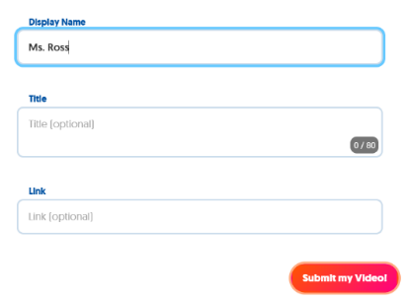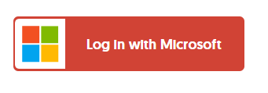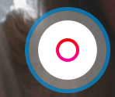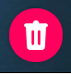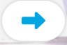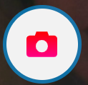

1. Click to add a response
2. Sign in with your 365

credentials

1. Launch the app
2. Enter the grid
3. Click to add video

\*Click to delete and start over

1. Click
2. Click to take your selfie
3. Click
4. Add (optional)
5. Enter info and submit