**Kindergarten Supply List**

In kindergarten learning to share is an

important skill. Please label only the items

that are specified. Thank you!

**This year you will need:**

-A backpack- no wheels and large enough to hold a folder, lunch box, and snack packed separately from lunch (**please label**)

-be sure to show your little one where you put their snack

-A plastic lunch box for a healthy lunch, please pack your snack in a separate container (**please label**)

-A thermos or water bottle that is no larger than 8 inches tall to be kept separate from the lunch box (in a large ziplock bag to avoid spills)

-2 plastic bottom pocket folders (**please label**)

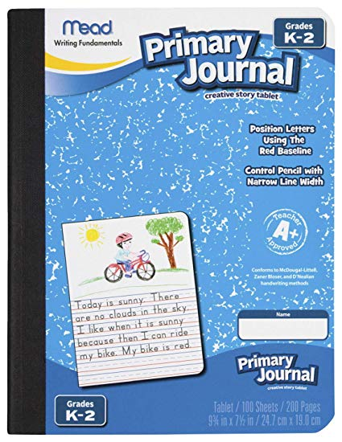

-1 Primary ruled K-2 Mead journal (**see picture ->**)

-12 sharpened pencils (Ticonderoga work best)

-2 large pink erasers (Pink Pearl work best)

-6 large Elmer’s (.77oz) glue sticks

-1 box of 8 Crayola large crayons

-4 boxes of 24 colors Crayola crayons

-1 box of 8 Crayola broad line washable markers

-1 box of Crayola colored pencils (**please put markers and colored pencils inside a large Ziploc bag and label**)

-4 Expo thin dry erase markers

-1 pair of Fiskar scissors (solid color please)

-1 package of 3x3 Post It Notes (please avoid the super sticky ☺)

-1 pack of assorted color construction paper

-3 large boxes of tissues

-5 containers of Antibacterial Wet Ones

-2 containers of Clorox disinfectant wipes

-A pair of headphones **inside a labeled Ziploc bag**

-A change of clothes in a Ziploc bag that will stay in your child’s backpack

-**girls:** one box gallon bags **boys:** one box sandwich bags (slider type work best)

**In addition the following classes will need/not need:**

**Mrs. Vilardi**- does not need Clorox wipes, does not need tissues, does not need

Post It Notes,

**Mrs. Jayner**-needs only one Antibacterial Wet Ones, does not need tissues, does

not need Post It Notes, does not need K-2 Primary Mead Journal, does not need Crayola markers, does not need Crayola colored pencils

**Mrs. Foppiano**- does not need Post It Notes, does not need Crayola colored

pencils

**Mrs. Caruso**- needs one binder pencil pouch (black please)

**Thank you!!!**

**Please bring the supplies to school on Thursday, September 5th ☺**

Back pack, one folder, lunch box, water thermos, change of clothes

can stay at home until Sept. 6th

