WebAssign Basics

WebAssign is a web-based homework utility that you will be using throughout the year. You will be given an assortment of questions from both your textbook and past Regents exams. In order to start using WebAssign, you will need to log onto a computer and go to www.webassign.com. Once here, you will see the following page.



Notice that over on the right hand side of the page, you will need to log into the system. Each student is given a distinct username and password.

- In the spot for Username, enter your first initial of your first name, followed by your last name, e.g. cropes.
- For Institution, type in ketcham.ny.
- For Password, type in your password. If it is your first time logging onto the system, your password will be physics.

You are now ready to get started.
The first time you log onto the system, you may see the following page:

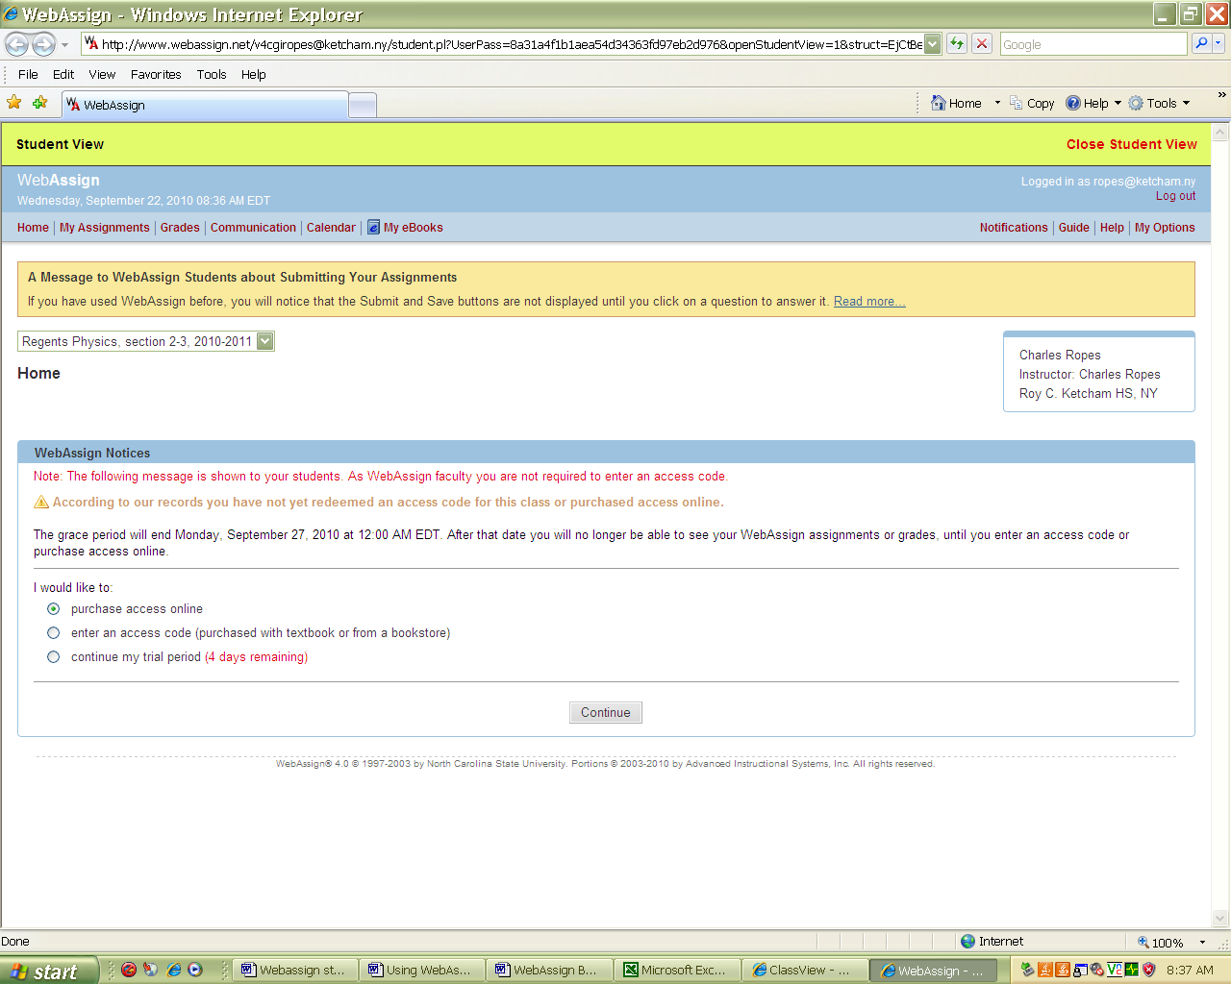
Click Here

Click on My Assignments

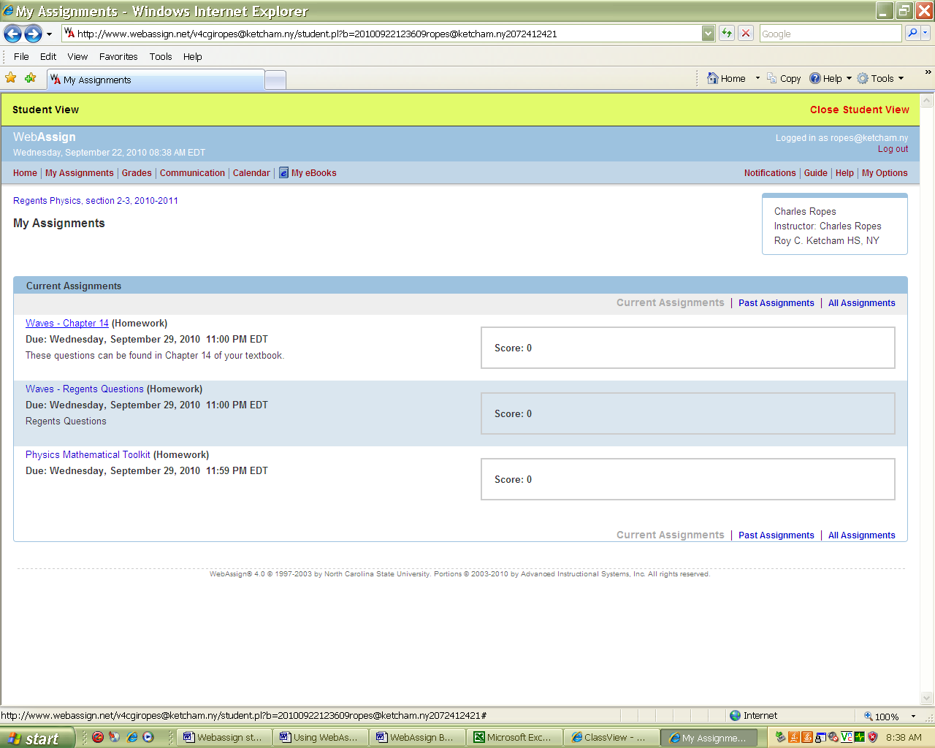
Click Here

You will then need to click on one of your current assignments.

You should then be directed to the following page where you can start answering questions.

