Title: The Principle of Linear Superposition

Theory:
- The principle of linear superposition says that when two or more waves are present simultaneously at the same place, the resultant disturbance is the sum of the disturbances from each individual wave. For example, if two waves, each with an amplitude, A, were to meet each other at a moment in time when both of them were at a maximum, the resultant amplitude of the wave resulting from these two waves would be 2A. The diagrams below provide examples of constructive and destructive interference. Constructive interference exists when two waves combine to form a maximum amplitude, positive or negative. On the other hand, destructive interference occurs when two waves combine to completely cancel each other out.
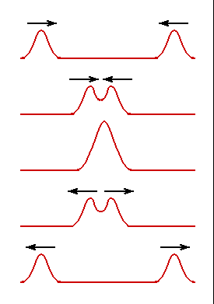

Constructive Interference
Destructive Interference
Objective:
- To learn to recognize the parts of a wave.
- To apply the law of superposition to two different waves.

Materials:
      - Paper
      - Pen or pencil
      - Ruler
      - French curve

Procedure:
      - Apply the law of superposition to determine the resulting wave pattern of two waves; one with the formula F(t) = sin(πt) and the other F(t) = sin (2πt).
      - Use values of t from 0s to 40s.
      - Trace the curve with colored pencil or marker.
      - Label axes and all curves clearly.

Analysis:
- What fundamental wave properties can be identified in each of the waves given on the back side of this sheet?
- What do you notice about the shape of the new wave formed? Describe what it looks like.
- Mark the graph where constructive interference is at a maximum, and where total destructive interference occurs.
- Describe the shape of the resultant waveform if you added F(t) = sin(πt) to F(t) = sin(-πt)?*
- Describe the resultant waveform if you added F(t) = sin(πt) to F(t) = cos(πt)?*

Error Analysis & Conclusions:

*If the answer is not clear to you, consider using Excel or a graphing calculator to answer the question.

