Name:___________________________________________ Semester:_________ Period:______
___/15

Directions: While viewing the presentation on “Teleprompter Technology” and the demo on using the ProPrompter, fill in the following blanks:

1) What is a teleprompter?
__________________________________________________________________________________________________________________________________________________________________________________

2) Where are teleprompters used today?
__________________________________________________________________________________________________________________________________________________________________________________

3) List 2 significant dates related to the history of the teleprompter:
__________________________________________________________________________________________________________________________________________________________________________________

4) Label the diagram below:

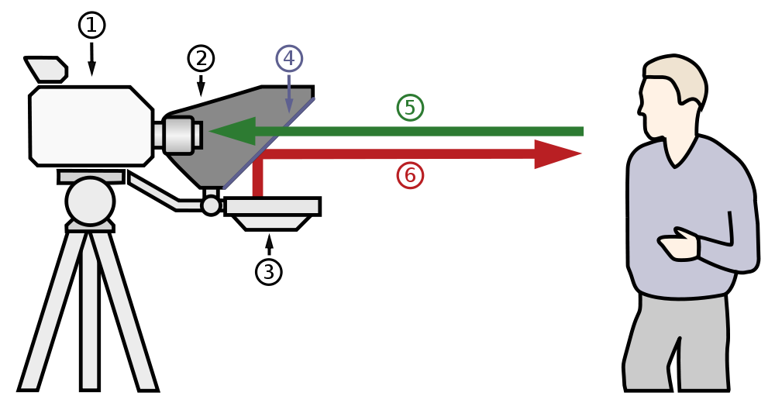

5) List 2 reasons why it’s important to lean how to use a teleprompter:
__________________________________________________________________________________________________________________________________________________________________________________

6) Why should you type your text (script) out in Microsoft Word first, before pasting your text into “ProPrompt” software?
__________________________________________________________________________________________________________________________________________________________________________________
