Screen Process Printing: Tools & Resources (Notes)

Computer Graphics
Total:_____/42
John Jay High School

Department of Technology Education

Name:________________________________________ Date:______________ Period:______

Directions: While viewing the PowerPoint presentation on “Screen Process Printing: Tools and Resources”, record notes and important information in the spaces provided below.

1) Why is it important to study the tools and resources of screen printing?
__________________________________________________________________________________________________________________________________________________________

2) Screen Frames
__________________________________________________________________________________________________________________________________________________________

3) Kerf
__________________________________________________________________________________________________________________________________________________________

4) Cord Setter
__________________________________________________________________________________________________________________________________________________________

5) Screen Fabric:
a. Monofilament:_________________________________________________________
b. Multifilament __________________________________________________________

6) Screen Degreaser
__________________________________________________________________________________________________________________________________________________________

7) Fabric Cleaning Brush
__________________________________________________________________________________________________________________________________________________________

8) Transparency Film
__________________________________________________________________________________________________________________________________________________________

9) Stencil and Ulano Film
__________________________________________________________________________________________________________________________________________________________

10) Exposure Cabinet
__________________________________________________________________________________________________________________________________________________________

11) Rollers
__________________________________________________________________________________________________________________________________________________________

12) Blockout
__________________________________________________________________________________________________________________________________________________________

Screen Process Printing: Tools & Resources ~Page 2

Computer Graphics
John Jay High School

Department of Technology Education

13) Ultrasoft Ink
__________________________________________________________________________________________________________________________________________________________

14) Squeegee
__________________________________________________________________________________________________________________________________________________________

15) Textile
__________________________________________________________________________________________________________________________________________________________

16) Heat Gun
__________________________________________________________________________________________________________________________________________________________

17) Screen Cleanup
__________________________________________________________________________________________________________________________________________________________

18) Stencil Remover
__________________________________________________________________________________________________________________________________________________________

19) How can you get extra help if you don’t understand screen process printing?
__________________________________________________________________________________________________________________________________________________________

20) Identify the following tool:

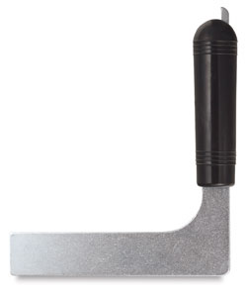
_____________________________

21) What is the purpose of the following tool:
__________________________________________________________________________________________________________________________________________________________



