Name: ____________________________________ Semester:_________ Period: _____

Did you know you could change the font of a section of text to customize the appearance of your Web Page?

WHAT IS A FONT… According to the web monkey
A font is the overall design for a set of characters. It describes the size, weight, and spacing of a character and shouldn't be confused with a typeface, which is a more general term. Courier is a typeface; Courier 24-point bold is a font. Computers display fonts in either a bitmap or a vector format. In a bitmapped font, each character is represented by an arrangement of dots. In a vector font system, the shape or outline of each character is defined geometrically. Since a vector font is scalable according to the defined outline, a vector system can make many differently sized fonts from one defined set of characters. Currently, the most widely used vector font systems are PostScript and TrueType.

PRACTICE AND APPLY – FONT COLOR
Open notepad and type the following HTML coding to display different font properties. Save your file in your HTML folder labeled lesson_02.html and open file in your Internet browser. Make sure you print your work and place your printed page under Lessons in your binder.

<HTML>
<HEAD>
<TITLE>Font Styles - YOUR NAME</TITLE>
</HEAD>
<BODY>

<FONT FACE="verdana"><H2>What is HTML?</H2>
<P>HTML is a computer language devised to allow website creation. These websites can then be viewed by anyone else connected to the Internet. It is relatively easy to learn, with the basics being accessible to most people in one sitting; and quite powerful in what it allows you to create. HTML is constantly undergoing revision and evolution to meet the demands and requirements of the growing Internet audience under the direction of the WC3, the organization charged with designing and maintaining the language.</FONT></P>

<FONT FACE="arial"><H2> The definition of HTML is HyperText Markup Language</H2>
<P> HyperText is the method by which you move around on the web - by clicking on special text called <B>hyperlinks</B> which bring you to the next page. The fact that it is hyper just means it is not linear - i.e. you can go to any place on the Internet whenever you want by clicking on links - there is no set order to do things in.</FONT></P>

<FONT FACE="courier"><H2>Okay, but what does H-T-M-L stand for?</H2>
<P><B>Hyper</B> is the opposite of linear. In the good old days - when a mouse was something the cat chased - computer programs ran linearly: when the program had executed one action it went to the next line and after that, the next line and so on.<BR><B>Text</B> is self-explanatory.<BR><B>Mark-up</B> is what you do with the text. You are marking up the text the same way you do in a text editing program with headings, bullets and bold text and so on. <BR><B>Language</B> is what HTML is. It uses many English words.
</FONT></P>

</BODY>
</HTML>

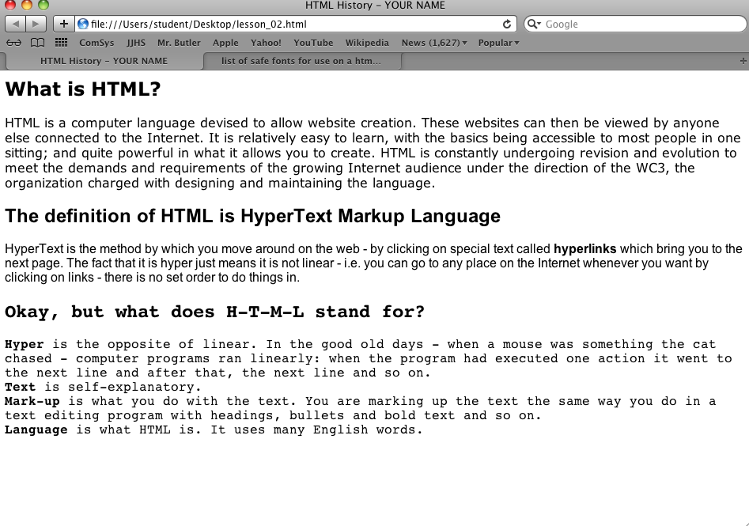

Example Fonts Faces:

