Notebook/Portfolio Organization (Activities)

Computer Graphics
John Jay High School

Department of Technology Education Mr. Butler

Name:_________________________________________ Date:____________ Period:_______

Directions: You will be creating Notebook Dividers for your course binder/portfolio. These dividers will help keep your work and course content organized. Using Microsoft Word, create the following cover pages for your notebook. Use your own creativity.
Page 1
Page 2

Your Name

Computer Graphics

Fall 2013

Instructor: Mr. Butler

Lab #167

Class Notes

Lessons

Page 3
Page 4

Assignments

Activities

Tutorials

Projects

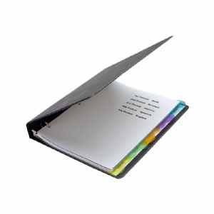

Tests & Quizzes

Page 5

