
Name:_______________________________________ Semester:____________ Period:_______
Estimated Class Time: 2 Days

Directions: Using Adobe Photoshop CS5 Classroom in a Book, you will be using your computer workstation, Photoshop CS5 program, and this worksheet to answer the following questions below. At the conclusion of completing this worksheet and tutorial lesson, you must call the instructor over for approval.

Starting to work in Adobe Photoshop:

1) In Photoshop you can import images from many sources, including: (pg 12)
__________________________________________________________________________________________

2) How do you restore Adobe Photoshop to default preferences on the Macintosh platform:
__________________________________________________________________________________________

3) Below is a Screen Capture of the Photoshop workspace. List the following components: (pg 13) 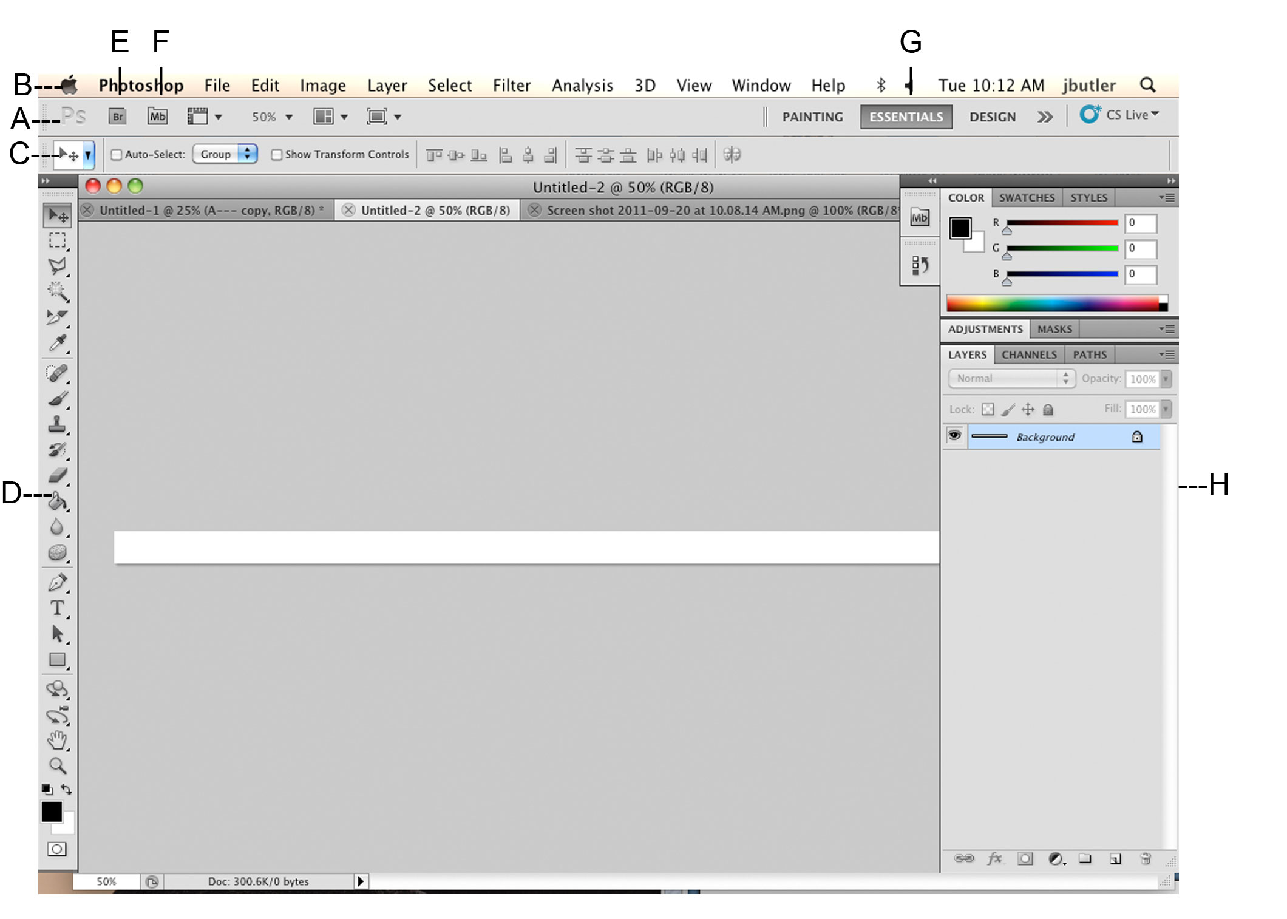

a:____________________________ b:____________________________

c:____________________________ d:____________________________
e:____________________________ f:____________________________
g:____________________________ h:____________________________
Selecting and using a hidden tool:

4) How do you recognize a hidden tool and how could you use a hidden tool? (pg 18)
____________________________________________________________________________________________________________________________________________________________________________________

Checking for updates:

5) Describe the process for updating Adobe Photoshop: (page 39)
____________________________________________________________________________________________________________________________________________________________________________________

Chapter Review Questions:

6) Describe two types of images you can open in Photoshop:

a) __________________________________________________________________________________

b) __________________________________________________________________________________

7) How do you open image files in Adobe Bridge?
____________________________________________________________________________________________________________________________________________________________________________________

8) How do you select tools in Photoshop (besides clicking on them)?
____________________________________________________________________________________________________________________________________________________________________________________

9) Describe two ways to change your view of an image:

a) __________________________________________________________________________________

b) __________________________________________________________________________________

10) List two ways to get more information about Photoshop:

a) __________________________________________________________________________________

b) __________________________________________________________________________________

Adobe Photoshop Tutorial Lesson 1 Completion:

TEACHER APPROVAL
20 PTS

