Logo Advertising Campaign (Projects)

Computer Graphics
John Jay High School

Department of Technology Education Mr. Butler

Name:_________________________________ Period: __________

Directions: Using your Adobe Illustrator skills and your previous knowledge of Computer Graphics, you will be creating a logo, which will be used on company letterhead and business card.

Remember: Make a new folder and label it __ __ (first and last initials) Logo
You will be creating three separate files in Adobe Illustrator for each product
- Logo
- Business Card
- Letterhead

What is a Logo: A logotype, commonly known as a logo, is the graphic element of a trademark or brand, which is set in a special typeface/font, or arranged in a particular, but legible, way. The shape, color, typeface, etc. should be distinctly different from others in a similar market.


Examples of Logos:










Look at the logo, business card, and layout books on display in the front of the classroom for ideas.
Step I: Thumbnail Sketches
You will sketch out twelve different thumbnail sketches of possible logo ideas. You must show your ideas to the instructor and receive approval before moving to step II. Shown below are example thumbnail sketches from a graphic designer who wanted to create a logo for his business. His idea was Five 54. The number Five 54 represents the degrees latitude and longitude of where he was born. Take a minute and analyze his ideas sketched below.
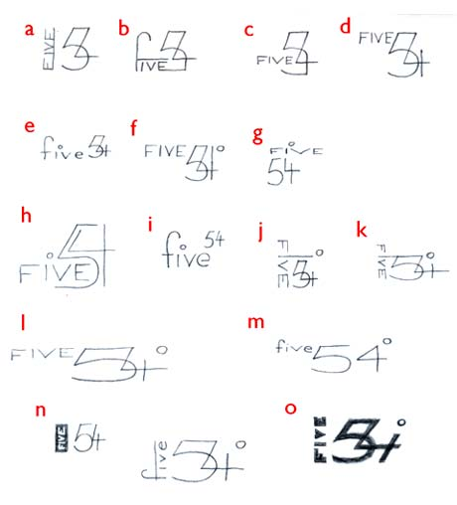

Thumbnail Sketch Instructor Approval: _________________ Date:____________
Step II: Rough Sketches
Chose one of your best ideas from your thumbnails. Make two different versions of it below; these are known as rough sketches. After you create your two rough sketches, see instructor for approval.

Rough Sketch Instructor Approval: _________________ Date:____________
Step III: Adobe Illustrator – Mechanical Layouts
After creating your thumbnail and rough sketches, you can start creating your mechanical layouts in Adobe Illustrator CS3. Feel free to experiment with different fonts, designs, colors, and layouts. You’ll know which ones works best. After you create your mechanical layouts on the computer, seek instructor approval.

Remember to follow proper file structure:
- __ __ (first and last initial) Logo
  - MechanicalLayouts
  - BusinessCard
  - Letterhead

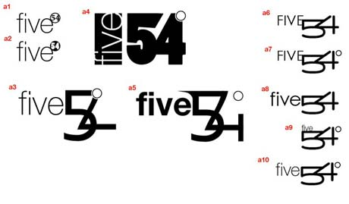
Below are examples of Mechanical Layouts designed in Illustrator from the designer of Five 54. Notice that each layout is unique. Remember expiermenting is an important stage to the graphic design process. When you have a vareity of Mechanical ayouts in Illustrator (5 or more), see instrcutor for approval.

Mechanical Layout Instructor Approval: _________________ Date:__________

Step IV: Business Card Layout
In Adobe Illustrator you will create a layout for your business card. Use the Principles and Elements of Design to create your business card layout. You will use the pre-made Adobe Illustrator blank templates by launching Adobe Illustrator and choosing Template →Basic →Blank Templates →Business Card 1_Blank.ait (Landscape), or Business Card 2_Blank.ait (Portrait). After you design your business card layout, see instructor for approval (page 5).
What is included in a business card:
- Logo
- Name & Title
- Address
- Phone and Fax
- Email address
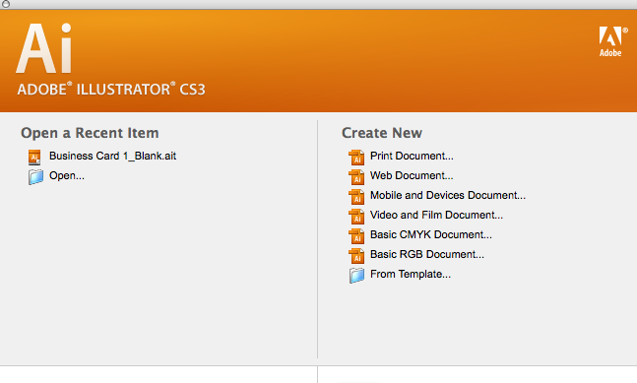
Open Business Card Template HERE

Example of a Landscape view business card

Business Card Instructor Approval: _________________ Date:____________

Step V: Letterhead Design
In Adobe Illustrator you will create a new blank document for designing your company letterhead. Be sure to label your letterhead, __ __letterhead and save it in your Project II folder. Your letterhead should include the minimum:
- Logo
- Name & Title
- Address
- Phone and Fax
- Email Address and Website information

Experiment with different designs and layouts for your letterhead. Study the example designs found on the World Wide Web, and layout books located on display in the front of the classroom. You’ll know which one works best! See instructor for approval.

Letterhead Instructor Approval: _________________ Date:__________

Name:____________________________________________ Period:______

Logo Grading Rubric:

Step I: Rough Sketches _____/15
- Did you sketch 12 different ideas? (12 points)
- Are the 12 ideas somewhat different from one another?
- Did you receive instructor approval before moving to step II (3 points)?

Step II: Rough Sketches _____/15
- Did you make two different clean sketches? (6 pts.)
- Could these sketches be scanned and traced in illustrator?
- Did you include color? (2 pts.)
- Did you put time and effort in your Rough sketches? (5 points)
- Did you get instructor approval? (2 points)

Step III: Mechanical Layout in Illustrator _____/15
- Does your illustrator logo resemble your rough sketches? (5 points)
- Does your logo contain RAW images? (2 points)
- Are all elements Vector Based? (5 points)
- Did you receive instructor approval (3 points)?

Step IV: Business Card Layout _____/20
- Does your business card contain proper contact information? (2 points)
- Is the lettering and logo placed to scale (not skewed)? (3 points)
- Is all information included and spelled correctly? (5 points)
- Is it evident that you researched business card designs? (5 points)
- Did you receive instructor approval? (5 points)

Step V: Letterhead Layout _____/20
- Is all information included and spelled correctly? (5 pts.)
- Is the logo placed and scaled appropriately (not skewed)? (5 pts.)
- Does your letterhead look professional? (5 pts.)
- Did you receive instructor approval? (5 pts.)

Step VI: File Sharing and File Structure _____/15
- Did you file share your Project II folder to the instructor computer? (8 points)
- Are all files included ? (4 pts.)
- Did you properly name your files (no spaces, no special characters, recognizable file names)? (3 pts.)

Project II Total: _____/100

