HTML Lesson 5 – Adding Images (Lessons)

Web Design & Production
John Jay High School

Department of Technology Education Mr. Butler

Name:___________________________________ Period:______

OBJECTIVE:
Adding Images to a website is an example of an Inline Image. These images are saved in the same directory as the host website folder.

REMEMBER:
- Images must be save as a Non-Native File Format (ex. .jpg, .gif, .tiff)
- An image created in Adobe Photoshop will save automatically as a “.psd” file, this is known as a RAW file/graphic (This is Native, and will not work online and must be converted).
- RAW/Native files must be converted to a Non-Native format; otherwise they cannot be read by Web Browsers. In Adobe Photoshop you can choose File → Save for Electronic Devices and Web
- Images must be save in the same location as your webpage file

TAGS
- Adding an Image <IMG SRC=”?”> replacing ? with the location of the image on your computer, example <IMG SRC=”bobcat.jpg”>
- Center a graphic or text <CENTER> </CENTER>
- Background Image <BODY BACKGROUND=“chocolate.jpg”>
- Define an image size by pixels <IMG SRC=“car.jpg” WIDTH=175 HEIGHT=117>
- Defining a Border in pixels <IMG SRC=“ski.jpg” BORDER=10>
- Wrap Text around the RIGHT side of an image <IMG SRC=”tiger.jpg” ALIGN=left>
- Wrap Text around the LEFT side of an image <IMG SRC=”tiger.jpg” ALIGN=right>
- Add Space around an image in pixels <IMG SRC=”tiger.jpg” ALIGN=left HSPACE=30>
- Adding a Horizontal Rule’s Size in pixels <HR SIZE=10>

<HTML>
<HEAD>
<TITLE>Mr. Butler's Zoo</TITLE>
</HEAD>
<BODY>

<BODY BACKGROUND="back.jpg">

<H1> <CENTER>MR. Butler's ZOO</CENTER></H1>
<IMG SRC="tiger.jpg">
<BR>
This is a picture of a tiger at my zoo. Watch out... Hess hungry!

</BODY>
</HTML>

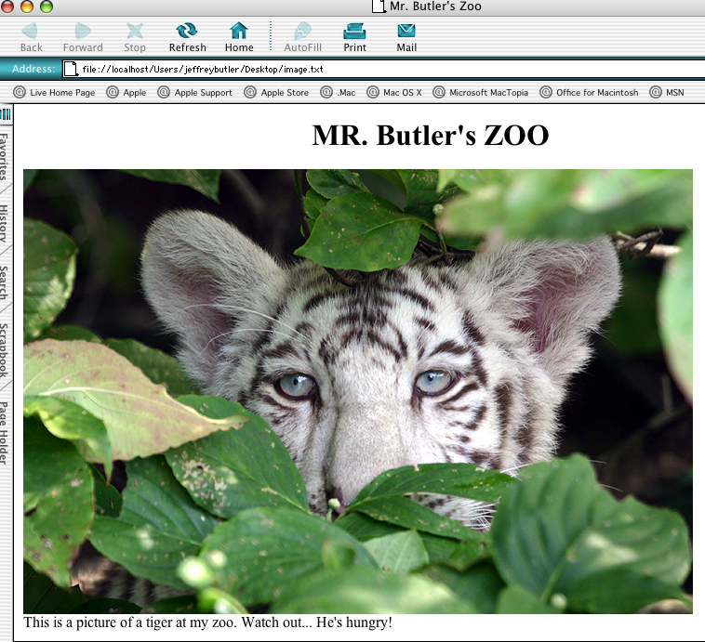

PRACTICE AND APPLY
- Using TextWrangler create a new HTML document
- Save your page as “_ _Lesson5.html” in your HTML folder.
- Create a new page and add a minimum of five images to your page!
  - Change Sizes
  - Format Position (Center, Left, Right)
- One image must be created in Adobe Photoshop (save as a non-native file format)
- Add Text by each picture, describing the picture
- Print your work on the HP LaserJet and hole punch
- Place your printed image page into your Lessons section of your binder.

