
Name:_______________________________________ Semester:____________ Period:_______
Estimated Class Time: 1.5 Days

Directions: Using Adobe Flash CS5 Classroom in a Book, you will be using your computer workstation, Flash CS5 program, and this worksheet to answer the following questions below. At the conclusion of completing this worksheet and tutorial lesson, you must call the instructor over for approval.

Getting to Know the Workspace:
1) In Adobe Flash, you can import elements from which other Adobe Programs?
__________________________________________________________________________________________

2) Label below, the five different work panels that are displayed by default when flash is first launched:

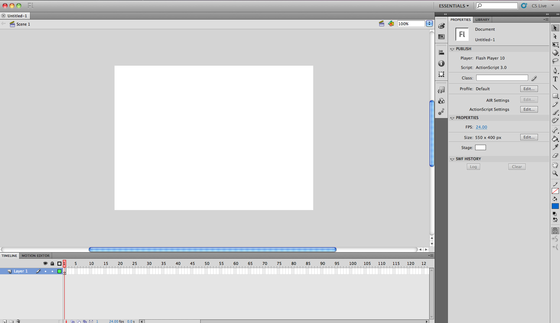
Choosing a New Workspace:
3) How can you rearrange the workspace in Flash or reset panel locations?
____________________________________________________________________________________________________________________________________________________________________________________

About the Stage:
4) What is the stage, and what is its purpose?
____________________________________________________________________________________________________________________________________________________________________________________

5) What stage features (list three) can you control in the State Properties control menu
- __________________________________
b) __________________________________
c) __________________________________

Library Panel:
6) What is the purpose of the library panel?
____________________________________________________________________________________________________________________________________________________________________________________
7) How do you import a photo to the library panel?
____________________________________________________________________________________________________________________________________________________________________________________

8) Describe how you can import multiple items into the library:
____________________________________________________________________________________________________________________________________________________________________________________

9) How do you add an item from the library into the stage?
____________________________________________________________________________________________________________________________________________________________________________________

Timeline:
10) What is a timeline?
____________________________________________________________________________________________________________________________________________________________________________________

11) Describe its function?
____________________________________________________________________________________________________________________________________________________________________________________

Layers:
12) What is a layer?
____________________________________________________________________________________________________________________________________________________________________________________

13) Why should you label ALL YOUR LAYERS?
____________________________________________________________________________________________________________________________________________________________________________________

14) Describe how layers can overlap each other: (How can this be done?)
____________________________________________________________________________________________________________________________________________________________________________________

15) Describe the process of adding and deleting layers:
____________________________________________________________________________________________________________________________________________________________________________________

Inserting Frames
16) How do you add more time on your timeline?
____________________________________________________________________________________________________________________________________________________________________________________

17) How do you select multiple Frames?
____________________________________________________________________________________________________________________________________________________________________________________

18) What is a Keyframe?
____________________________________________________________________________________________________________________________________________________________________________________

19) What is the purpose of the Empty Keyframe?
____________________________________________________________________________________________________________________________________________________________________________________
20) What is the purpose of a Filled Keyframe?
____________________________________________________________________________________________________________________________________________________________________________________

21) How do you remove Keyframes?
____________________________________________________________________________________________________________________________________________________________________________________

22) What’s the difference between a frame and a keyframe?
____________________________________________________________________________________________________________________________________________________________________________________

Organizing Layers in a Timeline
23) How can you organize layers in a Timeline?
____________________________________________________________________________________________________________________________________________________________________________________
24) How do you add layers to folders?
____________________________________________________________________________________________________________________________________________________________________________________

Using the Tools Panel
25) Describe what happen to the Properties Inspector when you select a tool?
____________________________________________________________________________________________________________________________________________________________________________________

26) List eight different tools can you find in the Tools Panel:
- __________________________________
b) __________________________________
c) __________________________________
- __________________________________
e) __________________________________
f) __________________________________
g) __________________________________
h) __________________________________

Undoing Steps in Flash
27) List two ways to undo a single step in flash:
- __________________________________
b) __________________________________

28) How can you undo multiple steps/actions in Flash?
____________________________________________________________________________________________________________________________________________________________________________________

29) Previewing and Publishing Your Movies
____________________________________________________________________________________________________________________________________________________________________________________

30) How do you preview your movie in Flash?
____________________________________________________________________________________________________________________________________________________________________________________

Finding Extra Help in Flash and Updates
31) How can you find extra help in Flash? ___________________________________________________________________________________________________________________________________________________________________________________

32) How do you update your flash program?
____________________________________________________________________________________________________________________________________________________________________________________

Adobe Flash Tutorial Lesson 1 Completion:

TEACHER APPROVAL

