Name:___________________________________ Semester:__________ Period:______

Introduction:
In this activity you will be designing a poster 24” x 36” (portrait) or 36” x 24” (landscape). In this activity you will be utilizing skills acquired in Adobe Photoshop. Previous knowledge from Photoshop lessons, Computer Generated Imagery (CGI), and digital photography should be utilized.

Design Challenge:
You will be looking for ideas for this Design Challenge: Adobe Photoshop Poster. You may use the internet and web resources for help getting inspired. A great example site is: www.AllPosters.com. After viewing examples, you should begin to see how the different graphic designers assembled their work. Think about the principles & elements of design, type, and use of imagery.

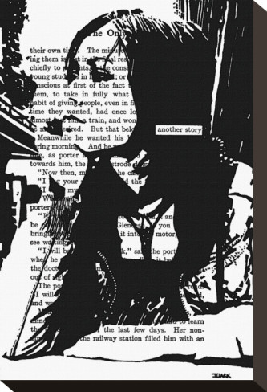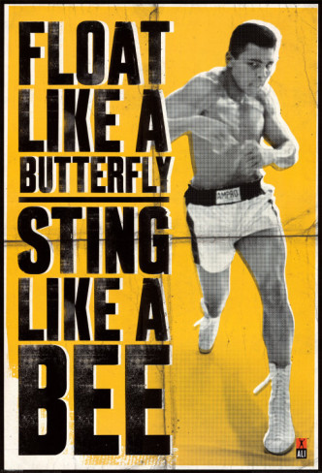

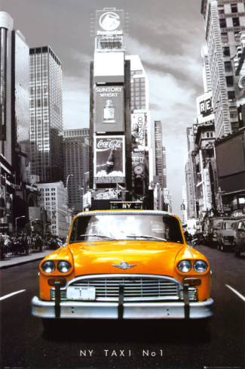
Directions:

Step One: Find Ideas
Search the web, look through magazines, make copies or save image that you would like to incorporate into your poster design.

Step Two: Project Folder and Photoshop Document
- Set up your new project folder titled: _ _ (First & Last Initial) design_poster ex: jb_design_poster
- Using Adobe Photoshop, start a new document with the following settings and save in your new folder.
  - Name: _ _ (First & Last Initial) Design_Poster
  - 24” x 36” (portrait) or 36” x 24” (landscape)
  - 300 ppi for resolution
  - RGB color mode
  - Save

Instructor Approval: ____________

Step Three: Project Description
Explain your project below. Think about what you are trying to convey. Is there a message or story you are trying to tell?
______________________________________________________________________________________________________________________________________________________________________________________________________________________________________________________________________________________________________________________________________________________________________________________________________________________________________________________________________________________________________________________________________________________________________________

Instructor Approval: ____________

Step Four: Begin Designing
- Use your newly created Adobe Photoshop document with appropriate dimensions from Step two.
- Label all layers
- Import digital photos using USB card reader
- Fonts should be saved in your project folder
- Check spelling (if applicable)
- SAVE, SAVE, SAVE – files are large and memory intensive

Instructor Approval: ____________

Step Five: Prepare for Printing
- Save working document
- Flatten, convert to CMYK, and SAVE AS _ _ (First & Last Initial) design_poster_FLAT

Instructor Approval: ____________

Step Six: File Share
File Share your whole project folder to JJ-167-TEACHER.

Instructor Approval: ____________

Grading Rubric

Student: _____________________________________ Poster Title: ____________________________________

Student Evaluation:
Describe your thought process for coming up with your final design solution. Think about the principles and elements of design applied, what did you learn about the design aspect of your poster? Did you encounter technical problems or learn technical knowledge while working on your poster design?
_____________________________________________________________________________________________________________________________________________________________________________________________________________________________________________________________________________________________________________________________________________________________________________________________________________________________________________________________________________________________________________________________________________________________________________________________________________________________________________________________________________________________________________________________________________________________________________________________________________________________________________________________________

Teacher Evaluation: ------------------------ DO NOT WRITE BELOW THIS LINE --------------------------------------------------

 | 0 Point  Unsatisfactory effort, does not utilize skills learned, weak, no proof of skill/missing, must improve, seeking extra help is encouraged. | 1 Point  Satisfactory effort, few skills learned or applied, needs to improve and try harder for next project, student should seek extra help. | 2 Points  Good effort, applied and utilized skills learned in class, creativity is present, | 3 Points  Excellent effort, above average, knowledge of skill is evident, understands and applies skills learned in class.
Planning
Project Summary
Evidence of Design Research
Photoshop File & Raw File Structure
Image Size & Resolution
Saved Correctly
Image Color Mode
Layers Labeled
Quality of Raw Imagery
Use of Photoshop Tools
Selection Tools
Filters
Quality of Manipulation Tools
Use of Text Tools
Layer Styles
Poster Design
Applied Principles & Elements of Design
Professional Appearance
Choice of Color Scheme
TOTAL: |  |  |  | _____ x 2=_____/90

Teacher Comments:
__________________________________________________________________________________________________________________________________________________________________________________________________

