Name:_________________________________________ Period:______ Semester: _____

HTML - Hyper Text Markup Language (Internet Format)
- HTML does not have a specific platform
- HTML reads from top to bottom, and left to right
- You do not need an expensive program to write HTML

Viewing HTML programming in your web browser
- Use View Source to look at code
- In the browser use File → Open to view your page in the browser

Saving HTML typed documents
- HTML documents must be saved as Text Only when you save your document as text
- Everyone should save to their documents in a newly create folder titled HTML Lessons

What do you need to create HTML Websites?
- Web Browser (Internet Explorer, Netscape, Fire Fox, Safari)
- A Word Processor (Microsoft Word or Apple Works)

Working with HTML Tags
Tags:
Each tag gives a specific instruction and is surrounded by angle brackets < >. Most tags have an opening tag and a closing tag that affect the text between the tags. The closing tag has a forward slash (/). Some tags have only an opening tag.
Attributes:
Some tags have attributes that offer options for the tag. For example, the <FONT> tag has a COLOR attribute that lets you change the color of text. You can use uppercase or lowercase letters when typing tags. Most people type tags in uppercase letters to make the tags stand out from the main text.
Web Page Structure:
Tags tell a Web browser about the structure of a Web page, but do not specifically define how to display the Web page. Each Web browser may interpret HTML tags differently, so a Web page may not look the same when displayed in different Web browsers.

Viewing Code for a Web Page
- Start the Web browser you want to use (I used Apple Safari)
- Click View
- Click Source
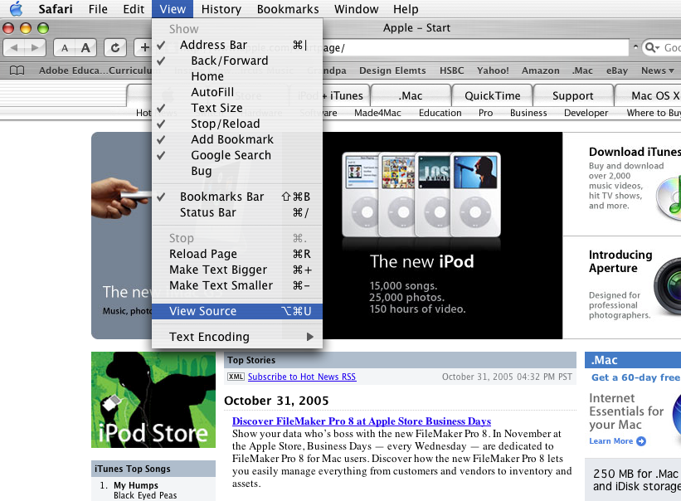

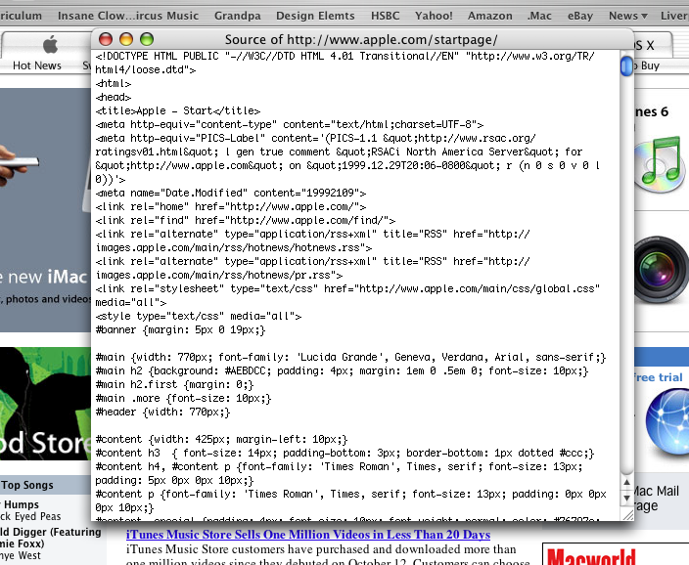

HTML TAGS

Certain sections are bigger, smaller, bolder, and underlined… HOW?
- Tags are also considered commands
- Tags begin with a less than sign <
- Tags end with a greater than sign >
- Learning HTML is specifying what the Tags do
- Always look like this < >

This Tag will turn Mr. Butler BOLD
<B>Mr.Butler</B>

- When you use a Tag you must always close the Tag to end a function Using </>

- Never leave spaces because the browser doesn’t read them anyway
- Most tags are easy to understand and what they do is obvious
Bold <B>
Italics <I>
Typewriter <TT>

Using two Tags at once
<B><I>Hello</I></B>

- What you turn on must be turned off in the same sequence

<HR> Horizontal Reference
<BR> Breaks the text and starts on the next line
<P> New Paragraph

Basic Hierarchy of HTML
- Must start every page with <HTML> and ends every page with </HTML>
- Then you must list the <HEAD> for the Heading and </HEAD>
- Next comes <TITLE> and </Title> this is inside the Head (This names the top of the document your viewing)
- The body of the HTML encloses the Main Content of the page <BODY> and </BODY>

Practice and Apply
Open Text Wrangler and copy the following HTML coding, Make sure you save your work “lesson_01.html”. Open your Internet browser and choose File → Open File and choose your text file to view it in the Internet browser. Print out your first webpage, staple it to this page, and place it in your binder under “Lessons”.
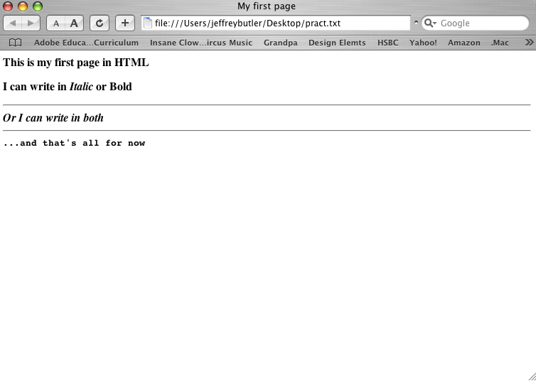
<HTML>
<HEAD>
<TITLE>My first page</TITLE>
</HEAD>
<BODY>
<B>This is my first page in HTML</B>
<P>I can write in<I>Italic</I> or <B>Bold</B><BR>
<HR>
<B><I>Or I can write in both</I></B><BR>
<HR>
<TT>…and that’s all for now</TT>
</BODY>
</HTML>

