Name: ________________________________________

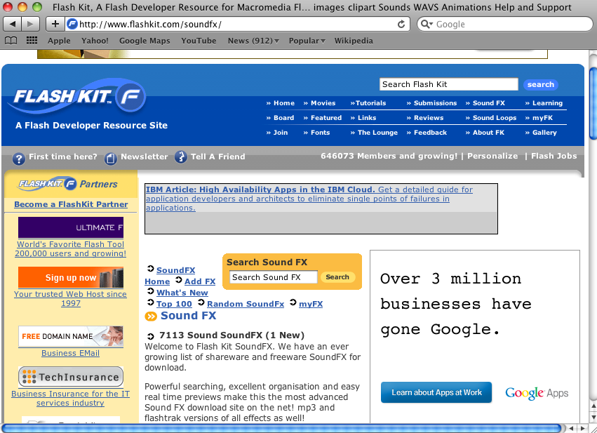
Adding Sound in Adobe Flash CS3

1) Search for Sounds on the Internet
Recommended Free Sound Websites:
www.FlashKit.com
www.FindSounds.com
www.SoundAmerica.com
www.FreePlayMusic.com

2) Download your sound file to a location on your computer
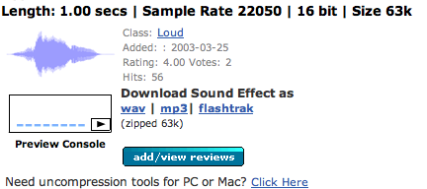

This is from FlashKit.com under SoundFx Library. Either “wav” or “mp3” formats work well.

3) Import your file to your library
File→ Import → Import to Library

4) Make a new Layer in your Flash Timeline for your newly imported Sound file.
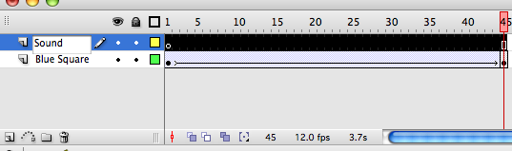
Always Label your layers as you create them. You can label your layers by double clicking their name

5) Select (by clicking) the keyframe you wish to have your sound file play. Insert a Keyframe by choosing: Insert→ Timeline→ Keyframe
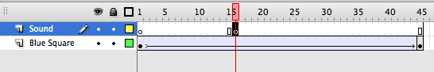

6) With your Library open, select and drag and drop your sound file anywhere onto the stage.
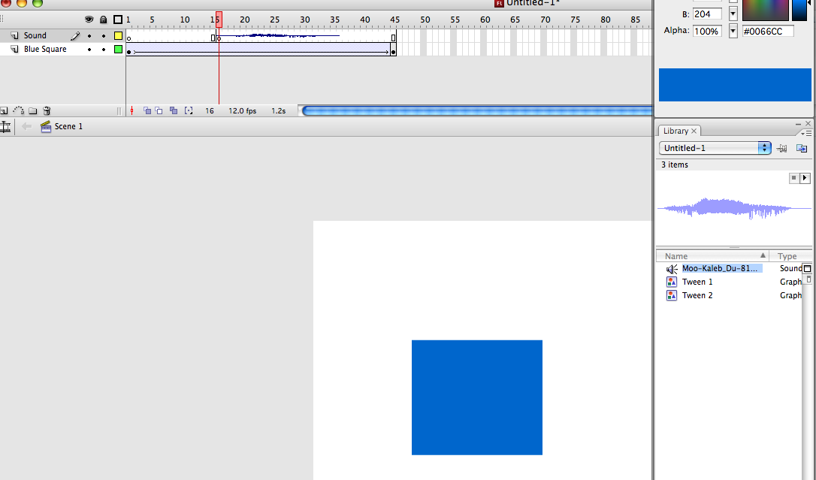

←DRAG

As you can see, the sound waveforms appear in your timeline sound layer (shown below)
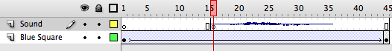

7) Test your movie by pressing Enter

Notes:
Sound and Music longer than your movie require simple stop actions, which is part of Action Scripting. For classroom projects, stick with short sound effect files.

