Fair Use Copyright in Education (Assignments)
____/36

Communication Systems
John Jay High School

Department of Technology Education Mr. Butler

Name:_________________________________ Period: __________

Introduction: In communication systems, you will be creating several multimedia activities incorporating the use of music and video. It is important to understand the laws and regulations associated with copyright material as it pertains to fair use in the classroom setting.

Directions: Using the Internet and the URL’s provided, answer the following questions:

- Define Copyright:
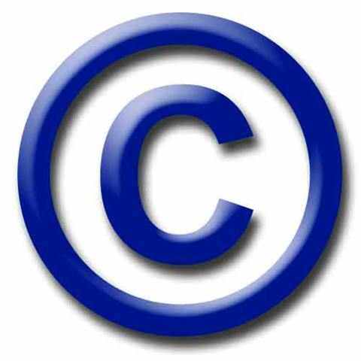

- Describe the Copyright Act of 1976:

- Define Fair Use:

Using the following URL, answer the following questions:

http://www.utsystem.edu/ogc/INTELLECTUALPROPERTY/ccmcguid.htm

- Is there a simple test to determine what is fair use? Explain.

- Who can authoritatively determine what is fair use?

- Explain (using your own words) Section 3.1 Student Use of the Fair Use Guidelines for Educational Multimedia:

- Define Portion Limitations of copyrighted work.

- What is the maximum amount of copyrighted Motion Media you can use in your educational project?

Fair Use Copyright in Education (Assignments) Page 2

Communication Systems
John Jay High School

Department of Technology Education Mr. Butler

- What is the maximum amount of copyrighted Music, Lyrics, and Music Video you can use in your educational project?

- What is the maximum amount of copyrighted Illustrations and Photographs you can use in your educational project?

- Explain (using your own words) Section 4.3 Copying and Distribution Limitations of the Fair Use Guidelines for Educational Multimedia:

- According to Section 5.3 Distribution of Multimedia Projects Beyond Limitations, can you upload your educational multimedia projects online through YouTube, MySpace, or any other sharing network? What are the exceptions?

