Name:________________________________________ Semester: _______

Launching and Setting Up Final Cut Pro Preferences:
1) Make a NEW project folder in your Communications Systems folder
- All your project files will be saved in here (Images, video clips, music, sound clips, project planning sheets, contracts, storyboards)
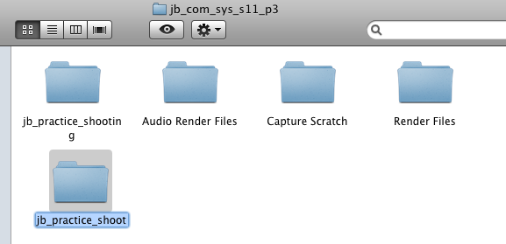

2) Launch Apple Final Cut Pro


3) Choose File → Save Project As
- Save your NEW Final Cut Pro Project in your newly created project folder
  - Label your new project _ _ (initials) project name
  - As you work, SAVE your projects frequently
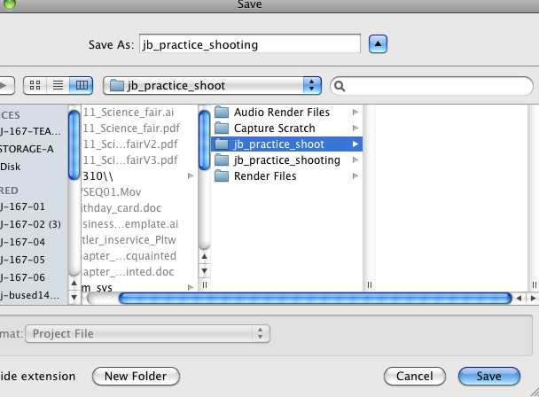

4) Choose Final Cut Pro → System Settings
- Set Scratch Disks tab
  - SET: Save Location, Waveform Cache, Thumbnail Cache, Autosave Vault
    - These all get SET to your newly created project folder
    - This tells FCP where all your media, and supporting files need to go.

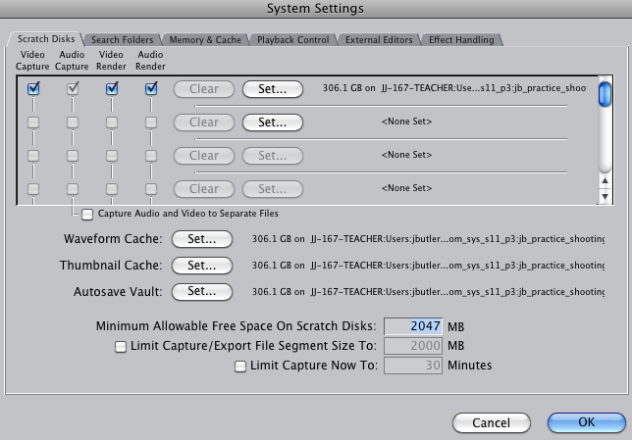

5) Choose Final Cut Pro → Easy Setup
For the following cameras, use the following settings:
  - Canon VIXIA HD: HDV-Apple Intermediate Codec 1080i60
  - SONY HDV 1080i A1U: HDV – 1080i60 FireWire Basic
  - Canon ZR500-ZR800 and JVC: DV-NTSC
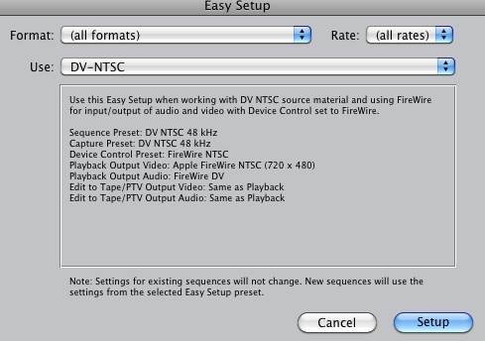

Importing Video Footage
Double Check to make sure your camera is OFF before plugging and un-plugging into FireWire or USB port!

6) To transfer your video from the camera into Final Cut Pro:
- If using a USB Card Reader, choose File → Log and Transfer
  - In the dialog box, select your clips and choose “Add Selection to Queue”
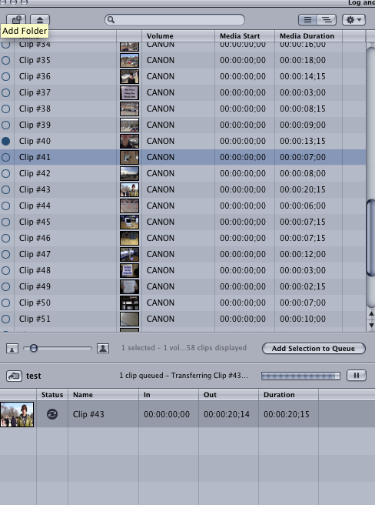
Choose Your Clips By Selecting Them
Choose “ADD SELECTION TO QUEUE”

- If using a camera connected via FireWire (4 pin to 6 pin), choose File → Log and Capture
  - In the Log & Capture dialog box, choose press the “Capture” “Now” button, and let your footage play through. You can control your camera through this dialog box.
UPON IMPORTING COMPLETION
Press “ESC”

Press the “STOP” icon

Power Camera OFF

UNPLUG FireWire Cable

Your clips will now appear in the Final Cut Pro clip browser window.

SAVE
Your Final Cut Pro Project!

HAPPY EDITING!
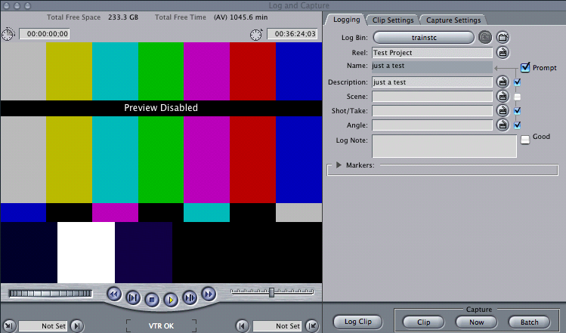
Control Camera’s Play, Rewind, Fast Forward, Pause
Choose Capture “NOW” to import your footage.
Press “ESC” when your footage is finished

