Name:___________________________________ Semester:__________ Period:______

Introduction:
In this activity you will be learning about the dye-sublimation print process to create your choice of a mug, or a set of four coasters. In this activity you will be utilizing skills acquired in Adobe Photoshop. Previous knowledge from Photoshop lessons, Computer Generated Imagery (CGI), and digital photography should be utilized.

Design Challenge:
Mugs and coasters are a great way to advertise and show-off ideas and thoughts to others.. You will be designing a mug or set of coasters, that will be given to a person as a gift. You will be utilizing the graphic design process to plan, sketch, and design this item.

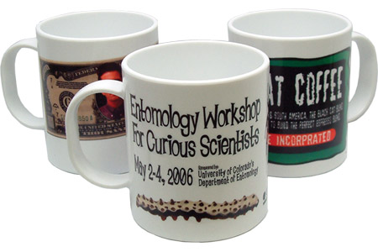
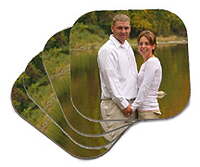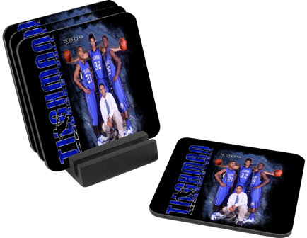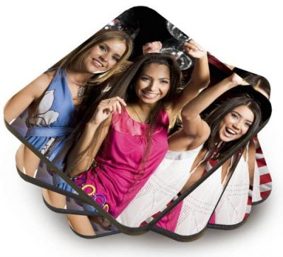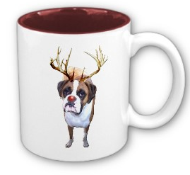
Directions:

Step One: Find Ideas
Search the web for mug designs or coaster designs (no not copy). Try to see what design process the designers are using to create their designs.

Step Two: Your Client
Who will you be designing your mug or coasters for? _________________________________
What are some of the things they would like to see on their mug/coaster set? (Hobbies, sports, work, actors, actresses, family members, pets, sayings)
_________________________________________________________________________________________________________________________________________________________________________________________________________________________________________________________________________________________________________________________________________________________________________________________________________________________________________________________________________________

Step Three: Sketch Design
Search the web for mug designs or coaster designs. Try to see what design process the designers used to create their designs.

MUG SKETCH:

COASTER SKETCHES: (you can do one coaster design, or four different designs)

Step Four: Project Folder and Photoshop Document
- Set up your new project folder titled: _ _ (First & Last Initial) dye_sublimation ex: jb_dye_sublimation
- Using Adobe Photoshop, start a new document with the following settings and save the file in your newly created project folder.
MUG
  - Name: _ _ (First & Last Initial) mug
  - 3.5 (height)” x 9” (wide)
  - 300 ppi for resolution
  - RGB color mode
  - Save

COASTERS*
  - Name: _ _ (First & Last Initial) coaster _
  - 4” x 4”
  - 300 ppi for resolution
  - RGB color mode
  - Save
  - *If you are doing four separate coaster designs, label and save each design NUMBERED in your project folder. Ex. jb_coster_01, jb_coaster_02, jb_coaster_03, jb_coaster_04.

Instructor Approval: ____________

Step Five: Begin Designing
- Use your newly created Adobe Photoshop document with appropriate dimensions from Step Four.
- Label all layers
- Import digital photos using USB card reader
- Fonts should be saved in your project folder (www.dafont.com)
- Check spelling (if applicable)
- SAVE, SAVE, SAVE – files are large and memory intensive

Instructor Approval: ____________

Step Six: Prepare for Printing
- Save working document
- Flatten, convert to CMYK, and SAVE AS _ _ (First & Last Initial) mug/coaster_FLAT

Instructor Approval: ____________

Step Seven: File Share
File Share your whole project folder to JJ-167-TEACHER into the Dye_Sublimation_Submit folder.

Instructor Approval: ____________

Grading Rubric

Student: _____________________________________ Poster Title: ____________________________________

Student Evaluation:
Describe your thought process for coming up with your final design solution. Think about the principles and elements of design applied, what did you learn about the design aspect of your mug or coaster design? Did you encounter technical problems or learn technical knowledge while working on your poster design?
___________________________________________________________________________________________________________________________________________________________________________________________________________________________________________________________________________________________________________________________________________________________________________________________________________________________________________________________________________________________________________________________________________________________________________________________________________________________________________________________________________

Teacher Evaluation: ------------------------ DO NOT WRITE BELOW THIS LINE --------------------------------------------------

 | 0 Point  Unsatisfactory effort, does not utilize skills learned, weak, no proof of skill/missing, must improve, seeking extra help is encouraged. | 1 Point  Satisfactory effort, few skills learned or applied, needs to improve and try harder for next project, student should seek extra help. | 2 Points  Good effort, applied and utilized skills learned in class, creativity is present, | 3 Points  Excellent effort, above average, knowledge of skill is evident, understands and applies skills learned in class.
Planning
Project Summary
Evidence of Design Research
Photoshop File & Raw File Structure
Image Size & Resolution
Saved Correctly
Image Color Mode
Layers Labeled
Quality of Raw Imagery
Use of Photoshop Tools
Selection Tools
Filters
Quality of Manipulation Tools
Use of Text Tools
Layer Styles
Mug/Coaster Design
Applied Principles & Elements of Design
Professional Appearance
Choice of Color Scheme
TOTAL: |  |  |  | _____ x 2=_____/90

Teacher Comments:
__________________________________________________________________________________________________________________________________________________________________________________________________

