Introduction to Basic Shooting (Notes)
___/20

Communication Systems
John Jay High School

Department of Technology Education Mr. Butler

Name:_____________________________________________ Date:__________ Period:_____

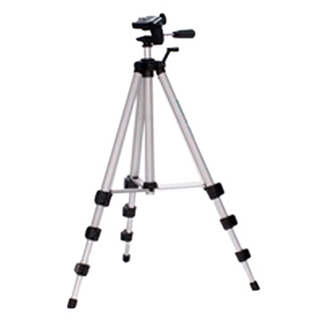
Directions: Using your previous knowledge and the video on “Basic Shooting: The Essential Guide to Basic Camcorder Techniques”, and answer he following questions.

BUTTON BASICS
What is the best way to manually focus a camera?
_______________________________________________________________________________________________________________________________________________________________________________________________________________________________________
What is the aperture (iris)?
_______________________________________________________________________________________________________________________________________________________________________________________________________________________________________

How do you adjust white balance?
_______________________________________________________________________________________________________________________________________________________________________________________________________________________________________

Why shouldn’t you use special effects (grayscale, sepia, crystallize) while shooting video?
_______________________________________________________________________________________________________________________________________________________________________________________________________________________________________
LIGHTING
When is the best time of the day to shoot video? Why?
_______________________________________________________________________________________________________________________________________________________________________________________________________________________________________

How would you bounce light onto an abject you shoot?
_______________________________________________________________________________________________________________________________________________________________________________________________________________________________________

What should you never do with indoor and outdoor light (Kelvin scale)?
_______________________________________________________________________________________________________________________________________________________________________________________________________________________________________
SOUND
How far should you stand from your talent if your using a built in camera mike?
_______________________________________________________________________________________________________________________________________________________________________________________________________________________________________

How would you improve sound when shooting video outdoors?
_______________________________________________________________________________________________________________________________________________________________________________________________________________________________________

Introduction to Basic Shooting (Notes) Page 2

Communication Systems
John Jay High School

Department of Technology Education Mr. Butler

What is a solution to excess wind noise?
_______________________________________________________________________________________________________________________________________________________________________________________________________________________________________
COMPOSITION
Describe the “rule of thirds”?
_______________________________________________________________________________________________________________________________________________________________________________________________________________________________________

Where should you shoot someone’s eyes when dealing with composition?
_______________________________________________________________________________________________________________________________________________________________________________________________________________________________________

What is “Look Room”?
_______________________________________________________________________________________________________________________________________________________________________________________________________________________________________
SMOOTH MOVES
What position should your feet be when shooting video?
_______________________________________________________________________________________________________________________________________________________________________________________________________________________________________

Describe hand, arm, and wrist placement when shooting video?
_______________________________________________________________________________________________________________________________________________________________________________________________________________________________________

How does optical image stabilization work?
_______________________________________________________________________________________________________________________________________________________________________________________________________________________________________

What is a pan?
_______________________________________________________________________________________________________________________________________________________________________________________________________________________________________

What is a tilt?
_______________________________________________________________________________________________________________________________________________________________________________________________________________________________________

What is a zoom?
_______________________________________________________________________________________________________________________________________________________________________________________________________________________________________

