AP Micro/Macro Economics
Mrs. Petrella
JJHS Room 225
Course D649

Dear Students and Parents,

Welcome to Advanced Placement Economic! Please read the following information so that you know what is expected throughout the coming year. Both the student and parent should sign the bottom of the second page and return to me no later than Wednesday, September 14th.

Course Objectives:
AP Economics is a full year course. The objectives for AP Economics consist of successfully completing the coursework for AP Microeconomics in the fall and AP Macroeconomics in the spring. Students will complete an in class final exam and take two AP Exams in May giving them the opportunity to earn 6 college credits. I will hold afterschool review sessions in the weeks leading up to the May examination focusing most heavily on the fall coursework.

In order to earn college credit you must pass the AP Exam(s). Depending on your chosen institution, scores of 3, 4, or 5 may be accepted for college credit.

* Students must pass the course in order to be eligible for a high school diploma and graduation.*

Final Exam
Part I – contains 30 multiple choice questions
Part II – contains one long response and one short response question from released AP exams

Required Materials:
Course Textbook provided for you: Principles of Economics; Makiw 6th Edition
Loose-leaf Binder – students are expected to keep handouts and notes organized.
Pens (blue or black ink)
Pencils
Suggested:
Colored pens or pencils will be helpful when graphing

Classroom Expectations:
- Be on time → in your seat and ready to work before the bell rings.

- Respect → me, your classmates, and yourself. My classroom will be a safe and comfortable learning environment for all students to participate. Put downs, inappropriate language, and negative comments will NOT be tolerated.

- Cheating will not be tolerated. You will receive a zero and a call home.

- If I see/hear a cell phone, IPOD/MP3 player, or other electronic device IT WILL BE TURNED INTO AN ADMINISTRATOR. Air pods should be removed from ears.

- Homework – Students will have on average 2 or 3 assignments per week. Homework will be collected, graded, and included as part of the course grade. All homework should be turned in on time. I DO NOT ACCEPT LATE WORK.

- Class work - will be collected, graded, and included as part of the course grade.

- Testing – Bi-weekly quizzes will be given.

- Make up work - If you missed school for either illness or a family emergency, you will have 3 days from when you return to make up any missed work. YOU are responsible to obtain any missed work. Students will not be allowed to make up work for illegal absences.

- Extra Help - I am in the Social Studies office by 7:15am each day and I am also available after school by appointment. If you have any questions/concerns please feel free to come and see me. I am available periods 2 & 8 for extra help, by appointment.

Grading:
Tests (50-100pts), Homework (10-30pts), Class work/Participation (10-20pts)

How to succeed in AP Economics:
If you come to class with a positive attitude, complete your work with care, participate in class, and see me if extra help is needed you will do well in this course. Remember, I am here to help you, not hurt your grade, but you need to do your part in order to succeed!!

Periodically, I will send out reminders for projects or long term assignments, get connected with Remind!
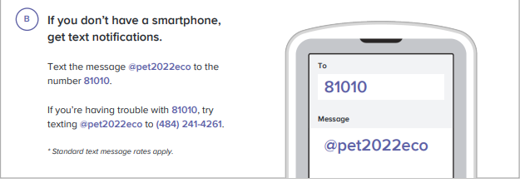
Parents:
I believe that it is important for parents to play an active role in their child’s education, even at the 11th and 12th grade level. Feel free to contact me with any questions or concerns you may have. I can be contacted at Alyson.Petrella@wcsdny.org or at 897-6700 x30062; e-mail is best. Website: http://www.wappingersschools.org/Domain/118

Sincerely,

Mrs. Petrella
Please sign and return, signifying you have read the course information provided, no later than Wednesday ________ / __________.

Student Name: ________________________ Student Signature: ________________________

Parent/Guardian Name:_______________________ ____________

Parent/Guardian Signature:________________________________

Please provide me with the telephone number or e-mail address that is best to contact you at in regard to your child’s progress in this course.

