New York State & The Erie Canal
Document-Based Question

Directions: This question is based on documents one through seven. The task is designed to test your ability to work with historical documents. As you analyze the documents, take into account both the source of each document and any point of view that may be presented in the document.

Historical Context:
During the 19th century, the construction of the Erie Canal led to the economic growth of New York City and the State of New York.

Task:
Using the information from the documents and your knowledge of social studies, answer the questions that follow each document in Part A. Your answers to these questions will help you write the Part B essay in which you will be asked to:

Discuss how the Erie Canal led to the economic growth of New York City and the State of New York.

Part A

Short-Answer Questions

Directions: Analyze the documents and answer the short-answer questions that follow each document in the space provided.

Document #1A

By 1824, the Erie Canal gave another boost to New York’s already busy seaports. Commercial vessels could now travel north up the Hudson River all the way to Lake Erie. This new waterway not only connected the Atlantic Ocean to the Great Lakes, it caused a terrific boom [increase] in the industry along the Hudson River and made on New York’s ports and harbor more valuable than ever.

Source: Virginia Schomp, New York Celebrates the States, Benchmark

Document #1B

Prior to construction of the canal, New York City was the nation’s fifth largest seaport behind Boston, Baltimore, Philadelphia, and New Orleans. Within 15 years of its opening [Erie Canal], New York City was the busiest port in America, moving tonnages greater than Boston Baltimore and New Orleans combined …

Source: New York State Canal Corporation

1A. Based on the documents, state one way the Erie Canal affected the economic growth of New York State.

________________________________________________________________

________________________________________________________________

1B. Based on the documents, state one way the Erie Canal affected the economic growth of New York City.

________________________________________________________________

________________________________________________________________

Document #2

Shipping Freight During the Erie Canal Era
(New York City to Buffalo)

 | Dirt Road | Erie Canal
Method | Wagon | Canal Boat
Amount of Time | 21 Days | 8 Days
Cost | $100/ton | $10/ton
Source: James Silver, American History Activities, The Center for Applied Research in Education (adapted)

2A According to this chart, how many days did it take to ship freight from New York City to Buffalo using the Erie Canal?

________________________________________________________________

2B. Using the information from the chart, state two economic advantages of using the Erie Canal instead of dirt roads to transport freight during the canal era.

- ______________________________________________________________________________________________________________________
- ______________________________________________________________________________________________________________________

Document #3
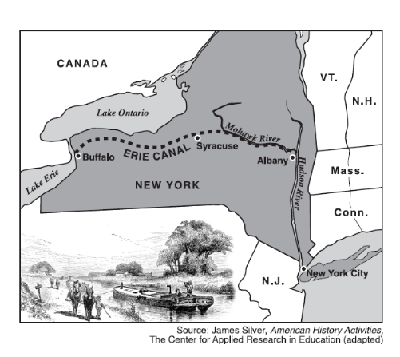

3. Based on the map, state one way the Erie Canal was important to the economic growth of New York State.

________________________________________________________________________________________________________________________________

Document #4
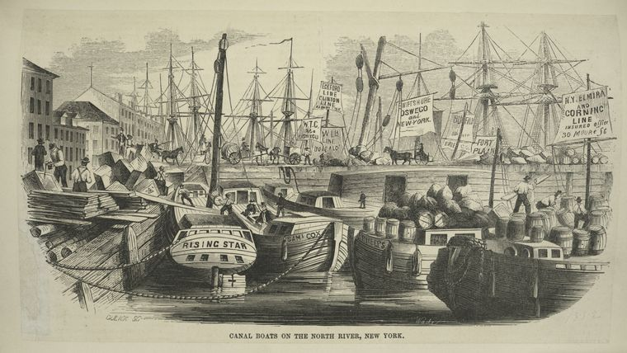

Source: Larkin, Daniels, & West, ed. Erie Canal – New York’s Gift to the Nation. Petersburg: Cobblestone Publishing, 2001.

Canal Boats on the North River, New York City

4. Based on the picture, what affect did the Erie Canal have on the port of New York City?

________________________________________________________________________
________________________________________________________________________

Document #5
Population of New York State Cities
City | 1825 | 1835
Albany | 10,000 | 28,100
Utica | 3,000 | 10,100
Syracuse | 1,800 | 7,800
Rochester | 1,500 | 14,400
Buffalo | 1,100 | 19,700

Source: Larkin, Daniels, & West, ed. Erie Canal – New York’s Gift to the Nation. Petersburg: Cobblestone Publishing, 2001.

5. What does the chart show about the effect of the Erie Canal on the population of Cities in New York State?

________________________________________________________________________________________________________________________________

Document #6
The movement of goods on the Erie Canal to and from Albany boosted an already prominent New York City to the status of chief business and financial center of the nation. When the canal opened in 1825, the additional grain and farm produce traveling through the city increased gross business by $6 million. Five hundred new commercial ventures sprang up in just the first few months after the opening. In April 1825, The Gazette, a local newspaper, carried 1,115 new advertisements. Also in that year, entrepreneurs established 12 new banks and 13 marine insurance companies, with aggregate investments of $23 million.
After the Erie Canal opened, new stores sprang up in New York City. They sold sugar, spices, coffee, hardware, and locally made imported textiles that were to be sent westward via the canal. Among stores clustered in lower Manhattan on the streets behind the waterfront was the New York Arcade, opened in 1827. Here, in the forerunner of today’s mall, shoppers could stroll through a protected sky lit corridor and make purchases at 40 shops.

Source: Larkin, Daniels, & West, ed. Erie Canal – New York’s Gift to the Nation. Petersburg: Cobblestone Publishing, 2001.

6. Based on this passage, state two ways the Erie Canal influenced the economic growth of New York City.

- ______________________________________________________________________________________________________________________
- ______________________________________________________________________________________________________________________

Document #7
Mule barges on the Erie Canal (1825)
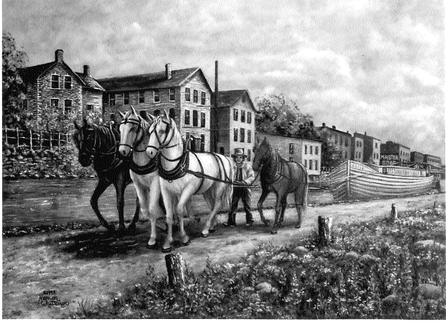

7A. Why were mules used on the Erie Canal?
________________________________________________________________________________________________________________________________

7B. Using the print, how did the Erie Canal impact Upstate New York?

______________________________________________________________________________________________________________________________

7C. Why did cities grow along the Erie Canal?
________________________________________________________________________________________________________________________________
Part B

Essay

Directions: Write a well-organized essay that includes an introduction, several paragraphs, and a conclusion. Use evidence from at least four documents in the body of the essay. Support your response with relevant facts, examples, and details. Include additional outside information.

Historical Context:
During the 19th century, the construction of the Erie Canal led to the economic growth of New York City and the State of New York.

Task:
Using information from the documents and your knowledge of social studies, write an essay in which you:

Discuss how the Erie Canal led to the economic growth of
New York City and the State of New York

In your essay, be sure to:
- address all aspects of the Task by accurately analyzing and
interpreting at least four documents.
- incorporate information from the documents in the body
of the essay.
- incorporate relevant outside information.
- support the theme with relevant facts, examples, and details.
- use a logical and clear pattern of organization.
- introduce the theme by establishing a framework that is beyond a
simple restatement of the Task or Historical Context and conclude
with a summation of the theme.

