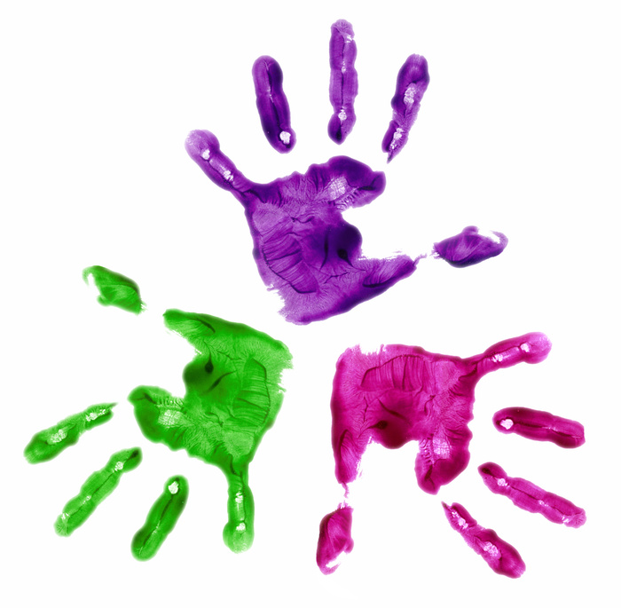
Dear Parent/Guardian,
Welcome to the Fishkill family. We are looking forward to having your child with us this fall. In preparation for entering Kindergarten, we have compiled a list of readiness activities that you can do with your child this summer. Your child does not need to master these skills, but practice can ease the transition into Kindergarten.
- Encourage your child to talk with you about their day.
- Read to your child. Talk about what was read, and ask them wh-questions (who, what, where, when, why, how) about the story.
- Practice rhyming.
- Work on letter formation. It’s important that all letters begin at the top. At Fishkill Elementary School, we use the Wilson Fundations program. Key terms that are associated with this program are the “sky line”, “plane line”, “grass line”, and “worm line”. See attached. Letter formation can be practiced in other non-traditional ways, including some of the following:
    - Fridge phonics (magnetic letters)
    - Sky-write letters
    - Alphabet BINGO
    - Finger-write letters on each others’ backs
    - Driveway writing
    - Draw letters in various materials (e.g. shaving cream)
- Practice letter sounds.
    - “I spy something that starts with ‘b’…”
- Play games together. Please see attached.
- Practice writing your child’s name.
- Teach your child their address and phone number.
- Practice cutting with scissors. Remember it is very important to hold your scissors correctly. Please see attached.
- Help your child learn how to follow directions.
    - Do the laundry together
    - Cook using a recipe
    - Have them set the table and clean up afterwards
    - Ask them to follow an unusual (“silly”) direction and then have your child develop a direction for you
- Sing the alphabet song.
- Teach/practice making shapes and numbers.
We hope you have a wonderful summer! See you in September.
☺ The Kindergarten Team

